Healthcare Group: Final Report

Introduction:
As a part of the Introduction to African American Studies class (AAS 100), the healthcare group undertook research to analyze the healthcare disparity in West Baltimore. Through the semester we were able to understand the healthcare disparity and its effects on the individuals in the Baltimore community. Through the first module (the traditional classroom experience, with an emphasis on team teaching and collaborative presentations), members attending the second module with peers at Morehouse College at the A3C Hip Hop Festival and the incorporation in module three with active researching and writing with the grassroots organizations in Baltimore, all the students were able to understand the situation of healthcare disparity in Baltimore. Lastly, five members attended the optional module four visiting Baltimore in December where they received first hand information through social interactions with members of the community.

Collaboration with Physicians for Criminal Justice Reform

Physicians for Criminal Justice Reform is a political advocacy group founded by a group of physicians who were struck by the myriad of ways that negative encounters with the criminal justice system lead to detrimental health consequences. Their mission is to advocate to eliminate the damaging health consequences that can result from negative interactions with the criminal justice system. Our group collaborated with Dr. Inzinga Harrison through PfCJR to sustain their needs of creating template for a platform where they could share articles that summarize the research they collected, blogs, and reviews to the general public.
We developed a template for a newsletter incorporating their logo, color scheme, and digested information that they hoped to share. Additionally, to be able to present information in an comprehendible format members of the group generated visual info graphs highlighting the statistics of the criminal justice system in the United States.
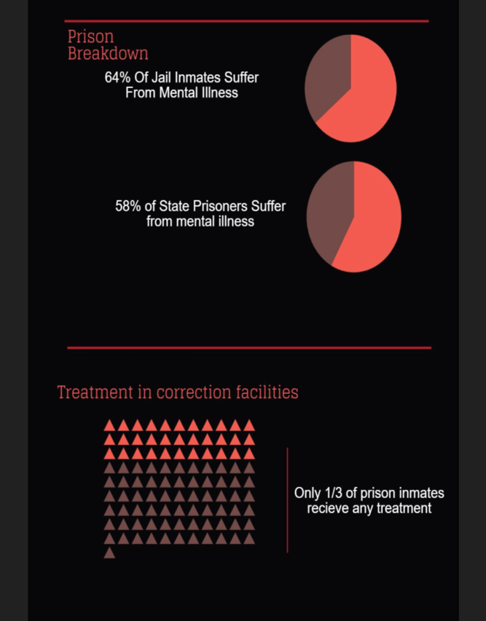
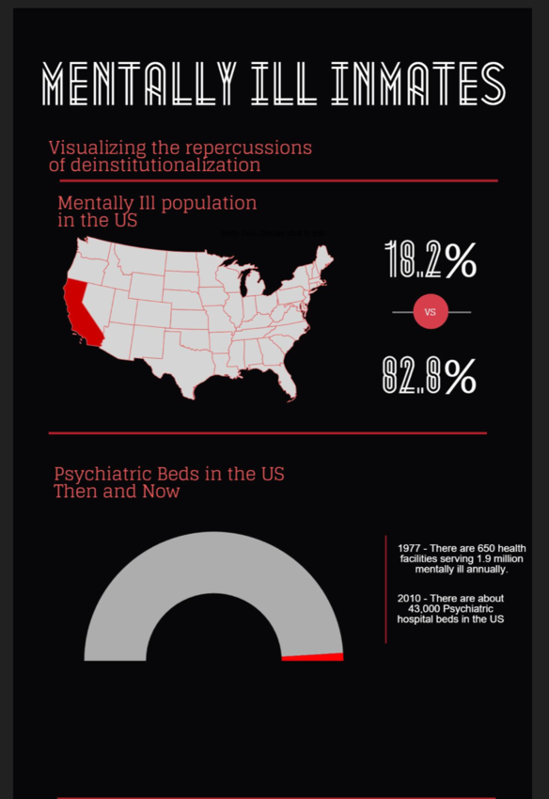

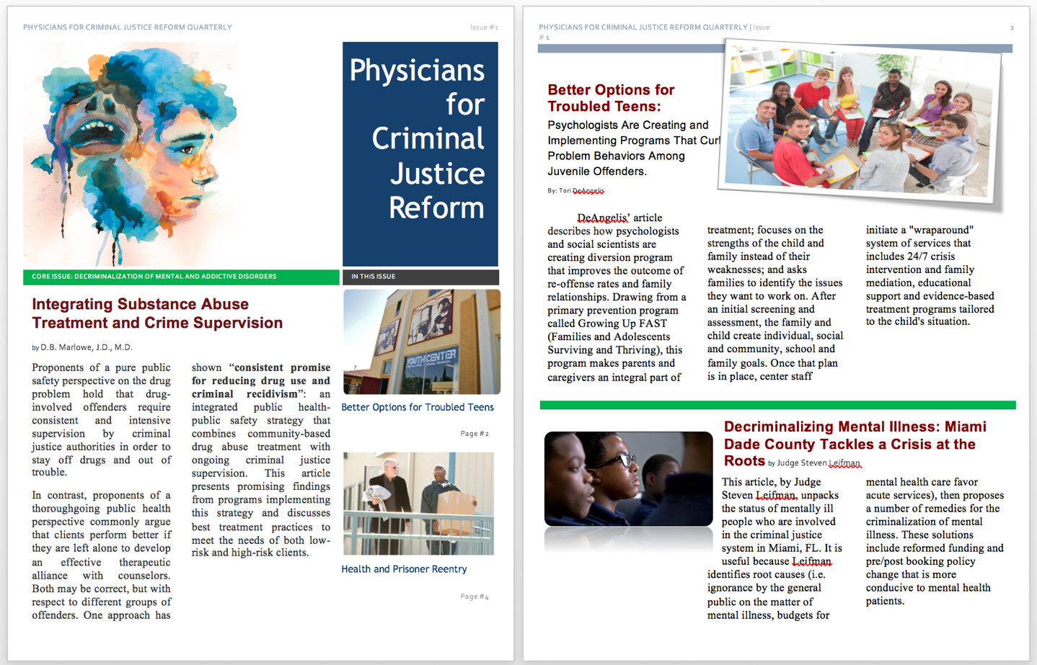
The other work that we conducted to support PfCJR was the use of social media and internet presence to increase awareness and knowledge of the bidirectional relationship between health and the criminal justice system through sites like Facebook, LinkedIn, Google+ and twitter where information can be shared to the masses. Although these were already in place, Dr. Harrison absorbed our ideas and suggestion and has incorporated them in her work.

Citation: "Physicians for Criminal Justice Reform." N.p., n.d. Web. <http://www.pfcjreform.org>.

Work in Baltimore: “Total Healthcare” with Dr. Janice Stevenson
Total healthcare is a nonprofit, tax-exempt community health center in West Baltimore. They allow families to receive the best care through the provision of care from doctors who are able to cater to the unique needs of residents in the Baltimore community. Total healthcare is accessible, has a drop-off pick-up service, and provides diagnosis and treatment to allow a speedy recovery to take place. Our collaboration involved an informal interview with Dr. Janice Stevenson who has worked with trauma recovery for over 30 years. She aids a large range of patients such as foster and delinquent youth, persons facing criminal charges, abuse victims of various types (abandonment, physical, emotional, sexual, and sexual), and persons facing life changing and life altering circumstances (divorce, marriage, job changes, and other changes in their circumstances).

Total Health Care. N.p., n.d. Web. Dec. 2015. <http://www.totalhealthcare.org/>.

Book Review: “The Immortal Life of Henrietta Lacks by Rebecca Skloot”
The Immortal Life of Henrietta Lacks by Rebecca Skloot effectively combines the racism seen within the medical system in the mid-twentieth to early twenty-first century. Henrietta Lacks was a black woman who died from cervical cancer at the age of thirty-one. After her death, doctors extracted the cancerous cells and stored them in a lab within Jon Hopkins University Hospital. Not expecting these cells to thrive in conditions outside of the human body, doctors grew them without her or her family’s knowledge. However, these cells were unique because of their ability to grow so effectively in a laboratory setting. HeLa cells (named after the first two letters of her first and last name) soon spread to labs all over the world, having a significant role in the scientific breakthroughs of leukemia, hemophilia, AIDs, and many more.
Instead of writing a book detailing the medical success of the HeLa cells, Skloot’s mission is to discover the history and story of the woman from which they came. Who was Henrietta Lacks? What is her life story? Especially in the medical field, doctors and researchers were obsessed with the HeLa cells and their widespread ability to cultivate outside a human body. However, they oftentimes did not stop to consider the woman behind the cells. Skloot pays special attention to the relationship between race, poverty, science, and the ways these intertwining concepts manifested themselves in a painful way in not only Henrietta Lacks’ life, but her children’s’ as well.
As a white woman, winning the trust of the Lacks family was no easy task. After many phone calls and visits, Skloot had to constantly prove that she was not calling to talk about the cells or take advantage of the impoverished family but to help them. This accentuates the ingrained general distrust of white people that is within the black population. After living without health insurance, remaining unaware about the HeLa cells, and being subject to a plethora of privacy violations, the Lacks family accepts Skloot’s help to uncover the truth about the cells. Before, the HeLa cells were a mystery to the Lacks family. Now, with the help of Skloot, they were about to uncover the truth about Henrietta Lacks, the cells, and the unfairness the black population constantly endures not only in Baltimore, but all over the country.
Many of the interactions in The Immortal Life of Henrietta Lacks are between Rebecca Skloot and Henrietta’s daughter, Deborah. Deborah does everything she can to understand the science behind these cells with Skloot’s help. This includes buying literature and dictionaries to understand the scientific implications behind these cells and even going to the mental asylum that her older sister, an epileptic, called home for many years. Rebecca Skloot and Deborah’s visit to The Hospital for the Negro Insane was a turning point. It is evident that black patients were not treated with the same resources and care as their white counterparts. The hospital was overcrowded, poorly managed, and understaffed. Moreover, caretakers performed scientific experiments on the inmates without familial consent. Skloot, through her in-depth analysis and motivation to learn about the woman behind the HeLa cells, proves that racial discrimination goes beyond everyday interactions. When Deborah learned of the dismal conditions Elsie lived in for many years, Skloot was kind, supportive, and respectful. She gave a mourning sister room to digest the day’s events. Her absence of abrasiveness gave Deborah the strength to finally hand Skloot Elsie’s medical records, helping both of them become one step closer to unearthing the story behind Henrietta Lacks.
After several bouts of political strife and gains in scientific knowledge, Rebecca Skloot helps Henrietta Lacks’ family learn more about the HeLa cells and their significance in the medical field. Serving as a mediator between the white and black population, she brings light to the injustice that Henrietta’s family faced and helped them realize their rightful place in the field of science despite the color of their skin.

Book Review: Infectious Fear

Infectious Fear: Politics, Disease, and the Health Effects of Segregation by Samuel Kelton Roberts explores the intersection of race and public health in America and emphasizes the relationship between health inequities and residential segregation, using tuberculosis as a central case study.
Chapter 1 of the book offers notes on the historical epidemiology of tuberculosis, emphasizing how important the timing of black populations’ exposure to the TB bacillus was and the ways in which it changed interactions with the environment and accounts of shifts in morbidity and mortality. Roberts presents a host of statistics which effectively show the elevated rates of mortality and morbidity among African Americans and the influence of living conditions during the time of infection. In this chapter Roberts provided his readers with the foundation for understanding the politics of race and tuberculosis in the early twentieth century.
After laying out his statistics, Roberts moves away from the numbers and examines the historical framework of TB which was one of the top three leading causes of mortality among urban African Americans in the early twentieth century. It affected single families in large segments of neighborhoods and has since been described as “a mysterious and fatal plague.” Roberts underlines how different institutions and individuals including black and white, public and private--responded to the challenges of tuberculosis in a segregated society. During this period of time, white politicians attempted to halt transmission across racial lines by enforcing Jim Crow quarantines for cases of the disease. This resulted in protest by the victims of the policy, urban Black Americans, targeting the root of the problem; segregated and overcrowded housing. After this historical briefing, Roberts explores and deconstructs what he calls “racial science” in the context of tuberculosis and the urbanization of blacks during this time by analyzing deterministic justifications for the disproportional incidence of tuberculosis for Black Americans as well as the lack of adequate treatment for poor Black individuals suffering from the disease. For instance, nurses directed to teach Black clients hygienic practices meant to limit the transmission of disease were most likely to be label their patients“incorrigible”. This was a type of client who was “unable to obey orders” and thus, was not eligible for treatment (pg 148). What Roberts is trying get across in this chapter is that the politics of black labor alongside the protests from economists, medical leaders and physicians, all served as factors in developing medical theory. What Roberts does exceptionally well here, is presenting the more than problematic published works of Frederick Hoffman and the counter arguments which followed from Du Bois’ and Kelly Miller. He concludes that segregation is, “a fundamental cause of illness, even if historians of Jim Crow have not included health deficits in full accounts of the wages of segregation” (p. 221) which he bases upon the health impact of restricting African Americans to systematically underdeveloped slum areas in cities: disproportionately high rates of transmission of airborne diseases. The massive migration of Black Americans away from the violence endured in southern towns into packed northern cities ensured that heightened disease incidence would be the natural result.
Following that thread, Infectious Fear pulled apart the politics of a typical encounter between a public health professional and a person of a disadvantaged group (racial and financial). Roberts acknowledged that there were other stigmatized tuberculosis patients in Baltimore, especially recent immigrants, but Black Americans suffered from the highest mortality rates from the disease.These numbers began to decline after 1935, but as this was the case for both white and Black populations, the author does not assume that meant reform of the racist implementation of public health services. He offers little to explain the change, only mentioning the arrival of more effective antibiotics.
After a thorough overview of the development of medical theory and practice in chapter 3, Roberts focuses his attention to what he describes as the “Landscape of Health”. The landscape of health is “both demographic and political, describing the distribution of health inequality and the broader political economy of uneven development within the cities that worked to produce it.” (70) Roberts writes about the effects of Jim Crow housing and the ghettoization of Baltimore’s Druid Hill corridor. The statistics which Roberts presents in this chapter compare the rates of mortality between blacks and whites suffering from things like typhoid fever and whooping cough in Baltimore. Roberts shifts from the relationship between uneven development in the city and political/ economic geography; this makes the book very structured and easy to follow. It is easy to appreciate the included statistical representation of all the information Roberts provides. Through his inclusion of various maps (especially in chapter 4), he examines the development of public health cartography which adds another perspective and complement his data nicely.
Roberts implies early on that the information in his book is valuable not only to better understand the tuberculosis crisis today, but also to ensure the failures of the past do not repeat themselves in the future with “new” immigrants. I think that because he stated in his introduction that his book offers potential solutions to future problems, perhaps he could have spent more energy focusing on the future solutions his book presents. The Journal of American History quotes Infectious Fear as a “meticulously researched, densely written survey of the bleak landscape inhabited by black Americans with tuberculosis (TB) during the Jim Crow era. . . . An insightful and sorrowful view of an important subject.” Overall the heavy statistical content of the work is not accessible for all readers and it does not fulfill the pretense of proposing future solution, but it ultimately reveals a disturbing picture of the United States' health history from which we can only hope to build a brighter future.

Annotated Bibliography

DeAngelis, Tori. “Better Options for Troubled Teens. Psychologists Are Creating and Implementing Programs That Curb Problem Behaviors Among Juvenile Offenders.” American Psychological Association. December 2011, Vol 42, No.11 Print version: page 69. <http://www.apa.org/monitor/2011/12/troubled-teens.aspx>

DeAngelis’ article describes how psychologists and social scientists are creating diversion program that improves the outcome of re-offense rates and family relationships. Drawing from a primary prevention program called Growing Up FAST (Families and Adolescents Surviving and Thriving), this program makes parents and caregivers an integral part of treatment; focuses on the strengths of the child and family instead of their weaknesses; and asks families to identify the issues they want to work on. After an initial screening and assessment, the family and child create individual, social and community, school and family goals. Once that plan is in place, center staff initiate a "wraparound" system of services that includes 24/7 crisis intervention and family mediation, educational support and evidence-based treatment programs tailored to the child's situation. (Core Issue: Identification and diversion of at-risk-youths)

Leifman, S. (2010). Decriminalizing Mental Illness: Miami Dade County Tackles a Crisis at the Roots. National Council Magazine, (1), 20-24. <http://www.scattergoodfoundation.org/sites/default/files/innovation- submissions/NC%20Mag%20Criminal%20justice%20Web-Email%20pdf_0.pdf>
This article, by Judge Steven Leifman, unpacks the status of mentally ill people who are involved in the criminal justice system in Miami, FL. It is useful because Leifman identifies root causes (i.e. ignorance by the general public on the matter of mental illness, budgets for mental health care favor acute services), then proposes a number of remedies for the criminalization of mental illness. These solutions include reformed funding and pre/post booking policy change that is more conducive to mental health patients. (Core Issue: Decriminalization of mental and addictive disorders)

Mallik-Kane, Kamala. "Health and Prisoner Reentry: How Physical, Mental, and Substance Abuse Conditions Shape the Process of Reintegration." URBAN INSTITUTE Justice Policy Center (2008): n. pag. Web. 10 Nov. 2015. <http://www.urban.org/sites/default/files/alfresco/publication-pdfs/411617-Health-and- Prisoner-Reentry.PDF>

The given source is a research report based on the general concepts of how physical mental and substance abuse conditions shape the process of reintegration. Additionally this report obtains the reentry experiences of prisoners with mental health conditions, relates to housing, employment, family support and many other issues faced by inmates. The report concludes with policy implications, methodology and an analysis of references used to produce the work. (Core Issue: Decriminalization of mental and addictive disorders)

Marlowe, D. B. (2003). "Integrating Substance Abuse Treatment and Criminal Justice Supervision." Science & Practice Perspectives, 2(1), 4–14. <http://www.ncbi.nlm.nih.gov/pmc/articles/PMC2851043/>

Abs: Proponents of a pure public safety perspective on the drug problem hold that drug-involved offenders require consistent and intensive supervision by criminal justice authorities in order to stay off drugs and out of trouble. In contrast, proponents of a thoroughgoing public health perspective commonly argue that clients perform better if they are left alone to develop an effective therapeutic alliance with counselors. Both may be correct, but with respect to different groups of offenders. One approach has shown consistent promise for reducing drug use and criminal recidivism: an integrated public health-public safety strategy that combines community-based drug abuse treatment with ongoing criminal justice supervision. This article presents promising findings from programs implementing this strategy and discusses best treatment practices to meet the needs of both low-risk and high-risk clients. (Core Issue: Decriminalization of mental and addictive disorders)

Munetz, Mark R et al. “Use of the Sequential Intercept Model as an Approach to Decriminalization of People With Serious Mental Illness.” Psychiatric Services 57.4 (2006): 544-549. Web. 11 November 2015.

For many years, there has been much discussion surrounding the overrepresentation of those with mental illnesses in prison. This article revolves around an intercept model that decriminalizes mental illness in communities. Additionally, it acknowledges that those with mental illnesses are more likely to be arrested. However, this does not mean that they should remain incarcerated due to mental condition and lack of access to proper healthcare. The Intercept Model contains points of intervention in which professionals meet with individuals suffering from mental illness and prevent them from circulating deeper into the criminality. One of the main goals of this model is to develop a functioning relationship between the mental health and criminal justice systems. (Core Issue: Identification and diversion of at-risk youths)
Wilkie, Christina. "A Bill To Keep Kids Out Of Prison Has A New Lease On Life, Thanks To Conservatives." The Huffington Post. TheHuffingtonPost.com, n.d. Web. 11 Nov. 2015. < http://www.huffingtonpost.com/2015/05/07/youth-promise-act_n_7232340.html>

This article is simply about reforming the juvenile justice system completely. Rather than paying for dealing with at-risk youths on the “back end” (prisons and police), pay on the “front end” (prevention). Democrats and Republicans came together this year in agreement on the benefits of the Youth PROMISE Act and the REDEEM Act. The PROMISE Act seeks to give grants to local governments exceeding no more than 10 million a year for programs that prevent juvenile delinquency. The REDEEM Act will keep minors and nonviolent offenders out of prison as well as seal criminal records to help offenders find employment. (Core Issue: Identification and diversion of at-risk youths)

