**Liberty 1**

**System Overview/Hardware** - I portray the Liberty 1 as a fluid (liquid) handling module with a microwave heating system that houses the reaction vessel (RV). The Liberty 1 fluidics module is responsible for:  
 A. Moving reagents from their reservoirs to the reaction vessel  
 B. Draining reagents from the reaction vessel to waste  
 C. Washing the flow path in between reagent addition steps and sending this to waste  
  
The Liberty 1 fluid handling module **meters reagents** using two mechanisms:  
 A. **Timed Addition** - This technique is used for the main wash solvent (DMF) and deprotection base solution (20% piperidine in DMF). It is used to deliver 'large' volumes of reagent.   
  
The System will pressurize the reagent bottle to ~ 15 psi with nitrogen (opens valves PMain and PE1 or PE9) and then opens the corresponding liquid valve (LE1 or LE9) and the valves corresponding to where you want the liquid to go (RV2 for waste or RV2/RV3 for the RV bottom or RV2/RV3/RV5 for the RV top) for a defined period of time. The reagent will flow into the flow path. After the pressure and liquid valves have been opened for their defined period of time, they will close and the flow path is purged with high pressure (turns on P23) to purge the reagent to its defined location (RV top, RV bottom or waste).

The purge step is for a defined period of time and then PMain, P23 and the destination valves are closed.  
  
Liquid (Optical) sensors are used to verify that the reagent is moving. It is X1, X2 and LS2 for the main wash. And X9 and LS2 for the deprotection base solution.

B. **Sample Loop Addition** - This technique is used for the amino acid, activator and activator base solutions.

The system will pressurize the reagent bottle to the low pressure of ~4 psi (opens P22, PMain and P1, PE10 or PE11). And then the system opens the reaction vessel top (RV2, RV3 and RV5) and the corresponding liquid valve (L1-20, LE10 or LE11). The valve remains open until the liquid sensor attached to the flow path tubing that corresponds to that reagent is triggered (the length of tubing between the valve and sensor corresponds to a known volume). Then the reagent reservoir pressure and liquid valves close along with the low pressure valve (P22). The system then purges the metered reagent in the flow path tubing to the reaction vessel (turns on P23).

The purge step is for a defined period of time and then PMain, P23 and the destination valves are closed.  
   
The liquid sensors for the Amino acid additions are labeled A1-20, for the Activator X10 and X12 and for the Activator Base X11 and X13. Also LS 2 is used to verify the reagent delivery to the RV.

The Liberty 1 will **drain the reaction vessel** by applying nitrogen pressure to the top of the reaction and opening the exit side of the vessel to waste. This is done by opening PMain, RV1 (to apply pressure to the reaction vessel) and RV3 (to open the exit side of the RV to waste.

The system will monitor the drain step using liquid sensors LS1 and LS2. The sensors will go from both on to both off to tell the system the drain step was completed successfully.

**Valves** - The valves are located in 3 different areas of the Liberty 1 fluidics module  
 A. **Amino Acid (AA) Valves** -   
 1. The AA liquid valves are located on the 4 amino acid manifolds directly behind the amino acid reservoir. These are the Kloehn 2 way valves. There are 20, one for each reservoir

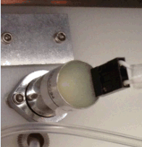

2. The AA pressure valve is located on the valve manifold (seen in the lower middle when you open the back door of the Liberty 1 fluidics module). It is an ActiveX style

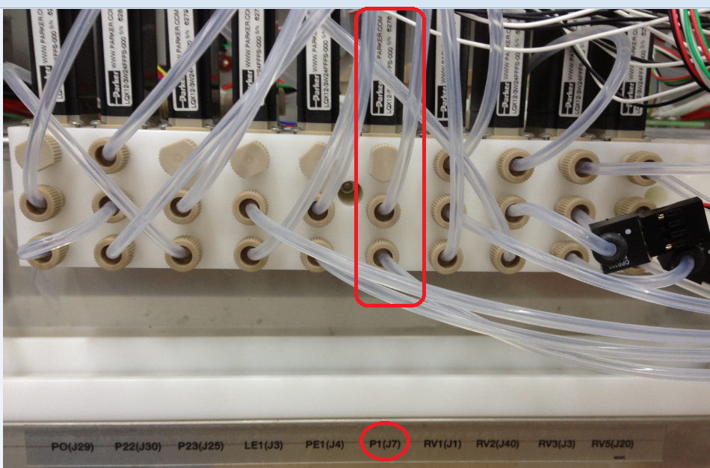

Valve. There is only 1 pressure valve for all 20 positions. (Therefore you need a bottle on all positions whether or not it is in use). The valves are labeled just underneath the manifold.

B. **External 2 Manifold** for Deprotection base, Activator and Activator Base Solution - The pressure and liquid valves for these 3 reservoirs are located on the external 2 manifold on the upper right as you face the rear of the system.

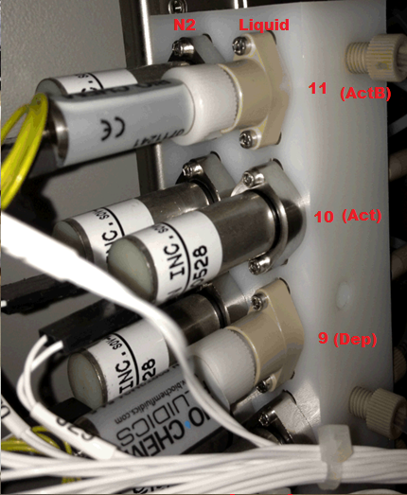

NOTE: The deprotection and activator base liquid positions show a BioChem valve – it can be replaced with a Kloehn valve.

NOTE: The valves for the optional capping feature would be located on the external 2 manifold below the deprotection valves.

C. **Main Wash Valves** - The pressure (PE1) and liquid (LE1) for the main wash (DMF) are located on the valve manifold.

D. **High and Low pressure valves** - The high (PMain) and low (P22) pressure valves are located on the valve manifold.

NOTE: For low pressure use, the system must vent prior to using low pressure and then open P22 first followed by PMain.

E. **Purge Valve** (or liquid/gas interface valve) - The purge valve (P23) is used to purge reagents from the flow path to the reaction vessel (or to waste) and is located on the valve manifold.

F. **Reaction Vessel valves** - There are four reaction vessel valves located on the manifold

1. RV2 - connects the main flow path to the waste container

2. RV2 and RV3 combination connects the main flow path to the RV bottom

3. RV2, RV3 and RV5 combination connects the main flow path the RV top

4. RV1 is the reaction vessel vent valve. When it is in the 'closed' position, it will vent the reaction vessel to the waste container (when you add reagents to the RV, it needs to be open to the waste container so the reagents can be added). When RV1 is open it will apply nitrogen gas to the reaction vessel (pressurize it for a drain step).

To drain the reaction vessel you will have valves RV1 and RV3 open.

NOTE: It is not intuitive and when the system drains, the waste will flow through the F3 filter, valves RV5, RV3 and RV2 to get to waste (even though RV5 and RV2 are in the off position).

**Liquid (optical) Sensors** - These sensors 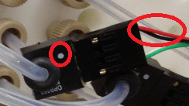 determine whether there is liquid or gas in the tubing where the sensor is attached (it provides just a yes/no signal). Sensors A1-20 and X10-12 are used to measure reagent delivery volumes. X1-2, X9 and LS1 and LS2 are used to monitor whether liquid is flowing when it should be flowing.

NOTE: When attaching the sensor to the connector, make sure the white dot on the sensor is on the same side as the black and red wires of the connector.

**Filters** - There are 3 filters  on the system. One is on the exit side of the external 2 manifold and before the reaction vessel assembly (Filter F2). The second is on the discharge side of the reaction vessel (ahead of RV5 it is Filter F3) just in case there is some problem with the glass frit in the reaction vessel. The third is on the reaction vessel vent line before RV1.

There are also ‘dip tube’ filters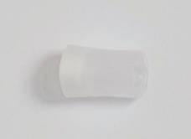 on the liquid lines for all solvents and reagents

The above covers the nuts and bolts of the Liberty 1 fluidics module.

**Trouble shooting**. I find that the best place to perform troubleshooting is from the Maintenance/Diagnostics 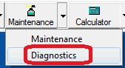 screen and from there go to the Valves window

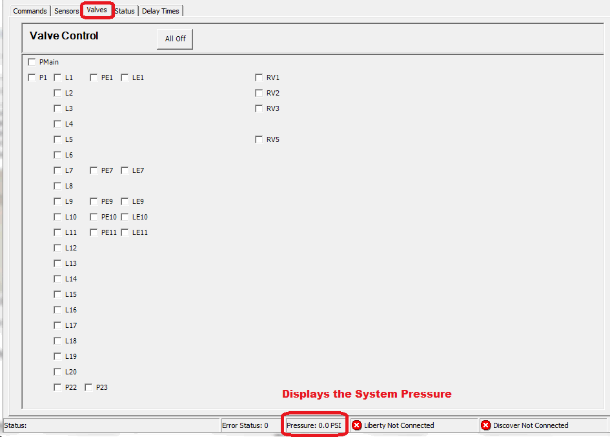

From this screen I can manually mimic every step the system will execute. You can easily determine where issues are. Some simple examples:

A. Turn on PMain, let pressure build and then turn off PMain - This will check for a **System leak**. When done click on P23 and RV2 to vent the system and after vented (<1 psi), click All off.

B. Turn on PMain, P23 and RV2 - This will **purge the main flow path to waste**. You should see a system pressure of 2-4 psi below the high pressure setting. When done, click off PMain to vent the system and after vented, click All off.

C. Turn on PMain, P23, RV2 and RV3 - This will purge the **main flow path to the bottom of the reaction vessel**. You should see a system pressure of 2-4 psi below the high pressure setting. When done, click off PMain and RV3 to vent the system and after vented, click All off.

D. Turn on PMain, P23, RV2, RV3 and RV5 - This will **purge the main flow path to the top of the reaction vessel (sprayhead)**. You should see a system pressure of 2-4 psi below the high pressure setting. When done, click off PMain, RV3 and RV5 to vent the system and after vented, click All off.

E. Turn on PMain, RV1 and RV3 - This will purge the **reaction vessel to waste**. You should see a system pressure of 2-4 psi below the high pressure setting. When done, click off PMain to vent the system and after vented, click All off.

Examples B-E are good to see if there is a restriction somewhere. Don't forget that a restriction can be due to Filter F2 located after external two manifold or Filter F3 after the RV exit port going to waste.

F. Turn on PMain and let the pressure build, then RV1 and let the pressure build to > 15 psi. Then click off PMain and watch the pressure. This will tell you if you have a **reaction vessel leak**. When done click on RV3 to vent the system and after vented, click All off.

G. Turn on PMain and let the pressure build, then PE1 and let the pressure build to > 15 psi. Then click off PMain and watch the pressure. This will tell you if you have a **leak in the Main Wash Solvent reservoir**. When done click off PE1 and click on P23 and RV2 to vent the system and after vented, click All off.

NOTE: The bottle cap for the main wash reservoir is different from the bottle caps for the deprotection base, activator and activator base reservoirs. The main wash bottle cap requires an o-ring. The main wash bottle will be more finicky than the other reagents in terms of a leak (you need to make sure the o-ring is seated properly when you perform a change bottle function).

H. Turn on PMain, P23 and look at all of the solvent/reagent reservoirs. If there is a l**eak in any of the liquid valves**, you will see bubbling in the corresponding reservoirs (Good way to see if there is a leak in the liquid valves).

All of the above actions are done with only nitrogen gas flowing through the system. They are useful for defining leaks or restrictions. The suggestive corrective action for **leaks** and **restrictions** are outlined below:

1. The most likely **leak** areas are either the RV or DMF bottle
2. RV
   1. Check the quick connect fitting
   2. Check the 1/8” PEEK nut/ferrule/tubing into the RV exit port
   3. Check the vent line at the RV manifold. It has an odd nut and a pair of needle nose pliers is handy.
   4. Submerge RV assembly into a beaker of water and turn on valves PMain and RV1. Do you see any bubbles?

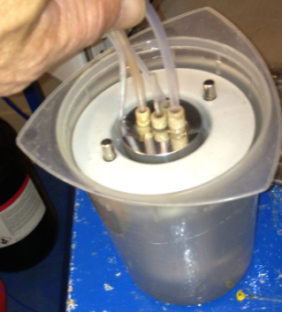

* 1. Using a toothbrush, apply soapy water onto RV manifold connections. Turn on PMain and RV 1. Do you see any bubbles on the connections?
  2. Backflush RV3 (see details below) – Disconnect tubing on exit side of the RV, turn on valve RV3 and using a syringe force methanol through the tubing to waste.
  3. Backflush RV1 – Remove RV, add ~ 20 mL of methanol to the RV and reconnect to the assembly head. Hold RV upside down while turning RV1 on and off. Methanol should flow through RV 1 to waste.

1. DMF bottle
   1. Check the bottle cap
   2. Check the bottle cap o-ring
   3. Check the fittings between the external manifold and the bottle caps.
   4. Check for chips on the bottle cap threads
   5. Turn on PMain and P23 – Is LE1 leaking?
2. The **restrictions** will be on the main flow path to waste/RV or in the exit path out of the RV to waste. Before trying to clear a restriction,
3. check the 2 waste (gas and liquid) lines going to the waste carboy for a kink and/or restriction.
4. And then check the F2/F3 filters. To do this, remove the 1/8” PEEK nut from the exit side of the filter. And then remove the 1/8” PEEK nut from the entry of the filter. The flow path is now open to the atmosphere
   1. F2 – Turn on PMain and P23 and read the pressure (it should be 7-10 psi). Click All Off and reattach the entry side of the filter to the 1/8” PEEK nut/tubing assembly. Turn on PMain and P23 and read the pressure (it should only increase 1-2 psi if the filter is not creating a restriction).
   2. F3 - Turn on PMain and RV1 and read the pressure (it should be 7-10 psi). Click All Off and reattach the entry side of the filter to the 1/8” PEEK nut/tubing assembly. Turn on PMain and RV1 and read the pressure (it should only increase 1-2 psi if the filter is not creating a restriction).

NOTE: When turning on PMain and RV1 and the pressure is > 15 psi, there is some restriction in the RV frit or between the exit port and the F3 filter.

After checking the waste lines and filters, proceed to flushing the flow paths with methanol.

1. **Main Flow Path to Waste or RV** – You will work from the Diagnostic/Valve Screen and need access to the rear of the System.
   1. Turn on PE1, P23 and RV2. Let the pressure drop to < 5 psi.
   2. Click All Off. Loosen one of the DMF bottle caps to release the remainder of the pressure in the bottles.
   3. Turn on PMain, P23 and LE1 to backpurge any residual DMF back into the bottle.
   4. Count to 10 and Click All Off.
   5. Using the hand tool 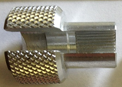disconnect the 1/8” PEEK fitting on the exit side of the ‘T’ fitting after valves LE1 and P23 to provide access to the main flow path.

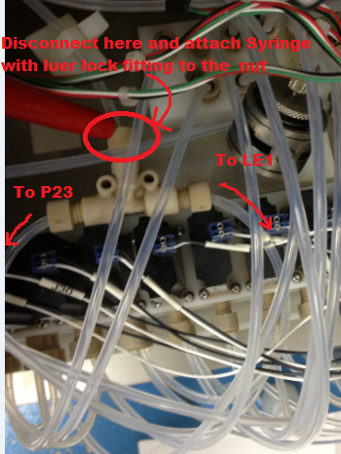

* 1. Attach a methanol filled syringe with luer tip fitting to the 1/8” PEEK nut removed from the ‘T’ fitting

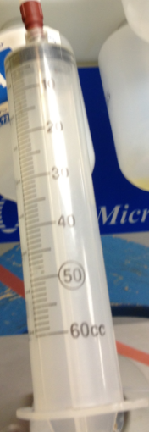

* 1. Click on RV 2 and squeeze methanol through the flow path to waste. If necessary, disconnect the syringe/luer tip from the fitting, refill with methanol and repeat.
  2. Click on RV3, disconnect the syringe/luer tip from the fitting, refill with methanol and repeat. You will see methanol going into the RV bottom
  3. Click on RV5, disconnect the syringe/luer tip from the fitting, refill with methanol and repeat. You will see methanol going into the RV top (sprayhead).
  4. Click All Off
  5. Remove the syringe/luer tip from the fitting and reattach the 1/8”PEEK nut/tubing assembly to the ‘T’ fitting (use the hand tool to tighten).
  6. Tighten the main wash bottle caps onto the bottles
  7. Turn on PMain, let the pressure stabilize to ~ 16 psi and click off PMain. Verify there is not a system leak and then proceed.
  8. Turn on PMain and PE1 and let the pressure build to 15 psi.
  9. Turn on LE1 and RV2.
  10. Click on the Sensors tab to check that the liquid is flowing. You will see this

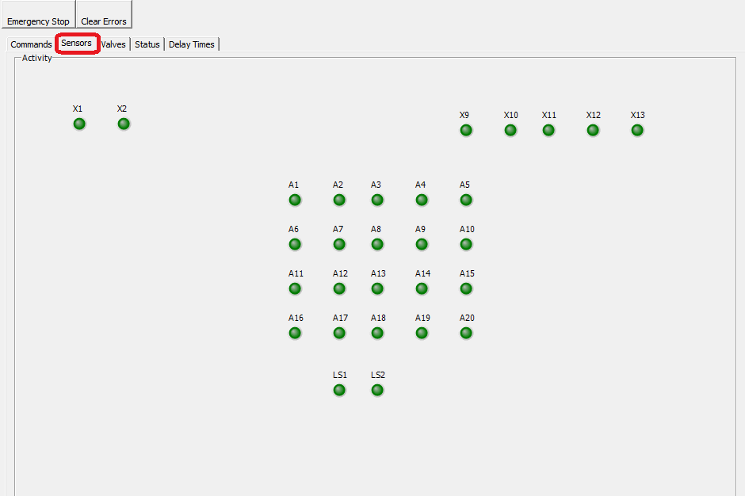

You should see all radio buttons go light green except for LS1. When they are all light green, click on the valves tab.

* 1. Click All Off and then PMain, P23 and RV2 on.
  2. Then click on the Sensor tab. You should see the radio button for each sensor go from light to dark green as the liquid goes to waste. When they are all dark green, click on the Valves tab
  3. Click off PMain and let the pressure drop to < 1 psi and then click All Off (The DMF bottle is primed now).

1. **RV to Waste Flow Path** - You will work from the Diagnostic/Valve Screen and want the RV in the calibration stand

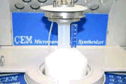.

* 1. Disconnect the 1/8” PEEK nut on the exit side of the quick connect fitting coming out of the RV exit port tubing.
  2. Attach a methanol filled syringe with luer tip fitting to the 1/8” PEEK nut removed from the quick connect fitting.
  3. Click on RV 3 and squeeze methanol through the flow path to waste. If necessary, disconnect the syringe/luer tip from the fitting, refill with methanol and repeat.
  4. Remove the syringe/luer tip from the fitting and reattach the 1/8”PEEK nut/tubing assembly to the quick connect fitting (use the hand tool to tighten).
  5. Turn on PMain and RV1, let the pressure stabilize to ~ 16 psi and click off PMain. Verify there is not an RV leak and then proceed.
  6. Click on the sensor tab. You should see LS1 and LS2 light green.
  7. Click on the Valve tab. Turn on PMain and RV3 to clear the RV exit flow path to waste.
  8. Click on the sensor tab. You should see LS1 and LS2 dark green. Then count to 5.
  9. Click on the Valves tab, click off PMain and let the pressure drop to < 1 psi. Click All Off.

**Forward Flushing a Liquid Valve** – If an amino acid solution is not being delivered from a reservoir and you have eliminated leaks and restrictions as a probable cause, the valve has crystallized solids in it or the valve has ‘failed’. Before assuming the valve has failed, forward flush the position to see if that solves the problem before changing the valve.

1. Remove the 125 mL reservoir from the manifold.
2. Remove the dip tube filter from the 1/8" dip tube.
3. Place the 1/8" PEEK nut and yellow flangeless ferrule (Insure the ferrule taper is positioned toward the PEEK nut) onto the dip tube

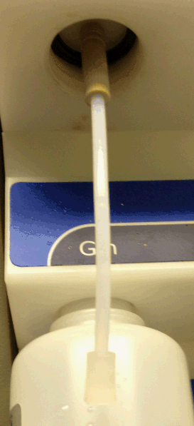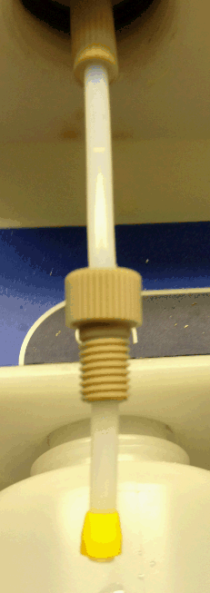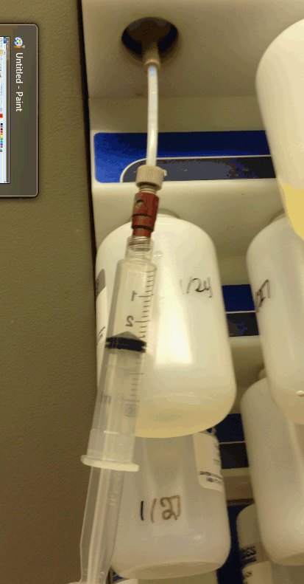

1. Fill the syringe/luer tip assembly with ~ 3-4 mL of methanol.
2. Attach the syringe/luer tip assembly to the 1/8" nut on the dip tube.
3. Click on RV 2 and the L valve corresponding to the reservoir position.
4. Depress the syringe plunger to 'squirt' methanol into the valve.
5. After you are able to get the methanol into the position, pull the plunger out and depress a couple of times to move the methanol back and forth through the valve.

NOTE: If you depress the plunger and it will not move, you still have block. You will want to try to squirt in methanol several times and also, open and close the valve several times. Ultimately the methanol will solubilize any amino acid crystals and free the block. If not, you need to change the valve

1. Now click off the L valve. And click on PMain, P23 to purge the main flow path to waste.
2. Click off PMain and let the pressure drop to < 1 psi and click all off.
3. Remove the syringe, ferrule and nut from the dip tube. Put on a fresh dip tube filter and reattach the reservoir into position.

**Changing Valves** – Before changing a valve, you want to

1. bleed the pressure off of the system (Open P23 and RV2, let the pressure fall to < 1 psi and click All off).
2. bleed the reservoir position (if applicable – open the corresponding PE valve, P23 and RV2 let the pressure fall to < 1 psi and click All off).
3. power down the Liberty 1 fluidics module.

Now for the specifics on each Valve type

1. **2 Way Kloehn Valve** – To change this valve you will need a replacement valve (including the 2 small o-rings), torque tool (located on the back door of the system) and a small piece of paper towel (or equivalent). You will need access to the rear of the system. Follow the instructions outlined in the video at this link <http://swedepwr.com/web/libpress.php> . Go to the Liberty1 Replacing 2 way valve.
2. **3 Way ActiveX Valve** - To change this valve you will need a replacement valve, 5/64” hex head wrench and a small piece of paper towel (or equivalent). You will need access to the rear of the system. Follow the instructions outlined in the video at this link <http://swedepwr.com/web/libpress.php> . Go to the Liberty1 Replacing way valve.

**Maintenance**

**Biweekly –** backflush the amino acid storage position using the function within the Maintenance/Maintenance feature of the PepDriver 1. This function will backflush and backpurge each selection. After performing this function, replace the dip tube filters.

**Monthly** – Calibrate the delivery rates for the time addition reagents (main wash top and bottom, deprotection base and capping <if applicable>).

**Quarterly** – Calibrate the Liquid Sensors. Outlined below is the recommended technique to calibrate the liquid sensors for the Liberty 1. They are a couple of routes to use to perform this and I am going to suggest working from the maintenance/diagnostic/valves and sensor screens. We will use the valves screen to fill up the flow path with DMF and the reaction vessel. Then we will close out the diagnostic screen and go to the Maintenance/maintenance/Sensor screen to perform the calibration. Then return to the diagnostics/Valves and sensors screens to check ourselves.

1. Remove the reaction vessel from the cavity and put it into the calibration stand (if it is not already there).
2. Open up maintenance/diagnostics/valve screen and maximize the screen to see the pressure value.
3. We want to first drain the reaction vessel and purge the flow path

a. Turn on PMain and let the pressure go to ~ 16 psi

b. Then click on RV1 and RV3. You should see the liquid flow out of the reaction vessel (if any was in there). When it is dry, count to 10 and click ALL off

c. Click on PMain, P23 and RV2. This will purge the flow path to waste.

d. Now click on the sensor tab. You will see the radio buttons for each sensor. They should all be dark green (they may flicker between dark and light green and that is OK).

e. Return to the Valve tab and click All off.

1. We will add some DMF to fill the flow path. So click on PMain, PE1, LE1, and RV2. When you see DMF coming out of the liquid waste line, click on RV3 to send DMF into the reaction vessel through the bottom. When you have about 15 mL of DMF in the RV click all off.
2. Click on the Sensor Tab to look at the sensors. They should all be light green now (this indicates liquid is in front of the liquid sensor and the liquid sensor is ‘seeing’ it).
3. Close out of the Diagnostic window and open Maintenance/maintenance and click on the Sensor Calibration tab. Now click on the Select All box (Note it will not take any action on LS2, that is done separately) and click on ‘Calibrate’ button  
     
   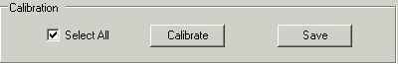

Note: After you select calibrate, it will ask if you want to fill the lines with DMF, say no since we already have done this.

1. A new calibration value will be determined for each sensor (except LS2) and recorded. When it is done you will want to save the data. As it saves the new calibration value is saved the ‘New Threshold’ column will be cleared and the ‘Current Threshold’ values will be updated with the new calibration value along with the date of the calibration. It will also ask if you want to drain the DMF. Say no, since we want to keep the DMF in the lines for the LS2 calibration.
2. A new window will appear to calibrate LS2.

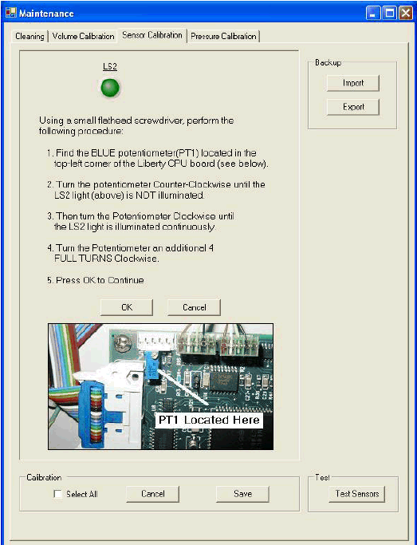

NOTE: You will need to open the rear door of the Liberty Blue so you can access the System's main CPU board located on the rear door.

Follow the instructions to calibrate this sensor (you will need a Jeweler's screw driver or a small spatula will work in a pinch).

1. When done save the calibration value but do not drain the system. We will do that manually.
2. Now close out of the maintenance screen and open Maintenance/Diagnostics and click on the sensor tab.
3. You will see all the sensors on this screen. They should all be light green indicating they see liquid. (If not stop and give me a call.)
4. Click on the valve tab. Click on PMain, P23 and RV2, This will purge the flow path to waste. Click on the Sensor tab; and watch the sensors go from light green (we see liquid) to dark green (we see gas) for all the sensors. You should be able to follow the flow path out of the system. After a short period of time, all should be dark green except LS 1 (it monitors the exit out of the bottom of the vessel.
5. Now click on the valve tab and click all off. Then click on PMain, RV1 and RV3 (this will drain the reaction vessel). Click on the sensor tab to see LS 1 go dark green.
6. Now click on the Valve tab. Click all off and then PMain, P23 and RV2. Leave them on for 10 seconds and then click off PMain until the pressure goes to < 1 psi and then All off. Now close out of the diagnostic screen.

Your sensors are now good to go. (If you are still getting red values, give me a call)

**Pressure Regulators** – The System has a ‘high’ and ‘low’ pressure regulator on it. The high pressure regulator is usually fairly stable. The low pressure regulator setting may change over time. The high pressure regulator should provide a pressure (valve PMain is on) of 15-17 psig and the low pressure regulator should provide a pressure (bleed system and then turn on P22 and PMain) of 3.5-4.5 psig.

Outlined below are the techniques to set (this is not a calibration – the only reason to recalibrate is if the zero value starts to creep up to > 1.0 psi) these two regulators if needed.

1. High Pressure Regulator
   1. Increase – To increase the setting
      1. go into the Diagnostics valve screen and click on PMain, P23 and RV2.
      2. Wait until the pressure stabilizes and then click off PMain
      3. Wait until the pressure goes to 0 and click all off
      4. Click on PMain
      5. Turn the green set screw clockwise until the gauge reads between 15-17 psig.
      6. Click on P23 and RV2
      7. Click Off PMain, let the pressure go to 0 and click All Off.
      8. Close out of the Diagnostics/Valve screen
   2. Decrease – To decrease the setting,
      1. go into the Diagnostics valve screen and click on PMain, P23 and RV2.
      2. Wait until the pressure stabilizes and then click off PMain
      3. Wait until the pressure goes to 0 and click all off
      4. Click on PMain, P23 and RV 2
      5. Then turn the green set green set screw counter clockwise until the gauge reads between 15-17 psig.
      6. Then click off P23 and RV2 to verify that the setting is between 15-17 psig.
      7. Click on P23 and RV2
      8. Click Off PMain, let the pressure go to 0 and click All Off.
      9. Close out of the Diagnostics/Valve screen
2. Low Pressure Regulator – The steps to change the low pressure regulator setting are best outlined in a video seen at this location <http://swedepwr.com/web/libpress.php> Go to the second video down (yes it reads Liberty 1 Low Pressure Calibration, but you are only setting it, not calibrating it).

**If the Liberty 1 is idle for > 2 Weeks or How to Flood it with Methanol**

The Liberty 1 System 'likes' to be run - If you have to let the system sit for > 2 weeks, I would suggest backflushing and flooding the system with Methanol. Methanol is much better than DMF since methanol will solubilize all reagents (with DMF some material may crash out over time).This will minimize the probability of any reagents precipitating out and causing restrictions. When you want to put the system back into use, will just purge the methanol out of the system and go about your business. I will cover these instructions below.

NOTE: You will find the instructions more daunting than the actual execution of them. So, please do not be put off by them.

It will take about 30 minutes to backflush and 'flood' the system with methanol. You will need a 1 or 0.5 L bottle about 1/2 full with methanol for this purpose (I suggest using a 1 L bottle with a GL 45 bottle cap since that will make it much easier than using a 4 L bottle). You will also want to have an empty 30 mL reaction vessel attached to the reaction vessel head assembly and in the calibration stand. The whole process will be done in the Maintenance/Diagnostics window under the Valves tab.

* 1. Depressurize and backpurge the Main Wash and Deprotection bottles
     1. Go to Maintenance/Diagnostics and then click on the valve tab.
     2. Expand the valve screen so you can read the pressure in the lower middle of the screen.
     3. Click on PE1, PE9, P23 and RV2.
     4. When the pressure is < 5 psi, click the All off button
     5. Unscrew the DMF and Deprotection base bottle caps
     6. Click on PMain, P23 and LE1. You will see bubbling in the DMF bottles. Count to 10 and then click off LE1
     7. Click on LE9. You will see bubbling in the deprotection bottle. Count to 10 and then click off All off.
     8. Click on P23 and RV 2. When the pressure is < 1 psi, click all off.

NOTE: I am not concerned about the Act, Act B and amino acid bottles since they will be at low pressure if there is a bottle present.

* 1. Remove the Reagent Bottle and the dip tube filter from the deprotection base, Act, ActB and the 20 amino acid positions. Then replace with a bottle to collect the backflush (except for the main wash position which will get a methanol bottle). When you put bottles to collect backflush, put on loosely (they do not have to hold pressure)
  2. Replace the main wash with a bottle of methanol (Use a spare 1 or 0.5 L bottle that is half full with methanol)
     1. Disconnect the nitrogen line followed by the liquid line from the "Y" connector that goes to the Liberty 1 manifold.
     2. Add 500 (300) mL of methanol to spare bottle and put on the bottle cap
     3. Using the nitrogen and liquid lines removed from the "Y" fitting in step 1, connect these two lines to the methanol bottle cap (make sure you get the nitrogen to the nitrogen side and the liquid to the liquid side).You now have methanol in the main wash supply position.

You are now ready to backflush the reagent storage positions and then flood the flow path with methanol.

* 1. We will first flood the flow path, then backflush the reagent bottle positions, the AA bottles. RV and waste lines.
     1. Click on PMain, PE1, LE1 and RV2 to flood the flow path.
     2. When you see methanol coming out of the liquid waste line, click on RV3 to add to the reaction vessel bottom.
     3. Count to 5 and then click on RV5 to add through the reaction vessel sprayhead.
     4. Count to 5 and click off RV2, RV3 and RV5
     5. Click on LE9 and count to 5 (you will see methanol going into the reagent bottle) and then click off LE9.
     6. Repeat this for LE10 and LE11.
     7. Now repeat this for L1-20.

The system has now been backflushed and it is now flooded with methanol. You will now let the system sit like this until you want to put it back into action.

**NOTE: If you have not performed a sensor calibration (this is a calibration of the optical sensors that monitor whether there is liquid or gas in the tubing that the optical sensor is attached to) within the last 3 months, you may want to do prior to purging the system and putting it back into routine use.** It will only cost you about 5 minutes of time. (See instructions above)

When you want to put it back into action, you want to purge all of the methanol out of the System, return the DMF to the main wash position and put on fresh reagents to appropriate positions. To do this, you will open up the Maintenance/Diagnostics window under the Valves and Sensors tab.

1. Click on PMain, P23 and RV2. You should see liquid coming out of the liquid waste
2. Click on the Sensor tab and wait until all are dark green except for LS1. Then click on the valves tab.
3. Click on RV3 and you should see bubbling in the reaction vessel. Count to 5 and move to the next step.
4. Click on RV5 and you should see liquid coming from the sprayhead. Count to 5 and move to the next step
5. Click All off and then click on PMain, RV1 and RV3 to drain the reaction vessel.
6. Click on the Sensor tab and wait until LS1 and LS2 go dark green, then click on the valves tab and click All Off.

The system has now been purged and you are ready to put the reagent reservoirs back into place.

1. Swap out the methanol back to DMF
   * 1. Click on P23, PE1 and RV2 to depressurize the bottle containing methanol.
     2. When the pressure is < 5 psi, click All off and loosen the bottle cap from the methanol bottle
     3. Click on PMain, P23 and LE1 to push methanol in the liquid line into the methanol bottle. Count to 5 and then click all off.
     4. Detach the nitrogen and liquid line from the methanol bottle cap
     5. Reattach the nitrogen and liquid lines removed from the methanol bottle cap to the Y connector for the DMF bottles(make sure they are connected to the correct port and are secure)
     6. Now click on PMain and PE1. When the pressure is > 13 psi, click on LE1 and RV2. When you see DMF in the liquid waste line (alternately you can click on the sensor tab and when LS2 is light green, go back to the valves screen), click All Off.
     7. Now click on PMain, P23 and RV2 and click on the sensor tab. When LS2 is dark green, go back to the valve tab and click off PMain. When the pressure is < 1 psi, click All off.
2. Prepare the Deprotection Base solution for operation
   * 1. Put a fresh dip tube filter on the deprotection base line
     2. Add deprotection base soln to its bottle and screw the bottle into the bottle cap.
     3. Now click on PMain and PE9. When the pressure is > 13 psi, click on LE9, and RV2. When you see deprotect in the liquid waste line (alternately you can click on the sensor tab and when LS2 is light green, go back to the valves screen), click All off.
     4. Now click on PMain, P23 and RV2 and click on the sensor tab. When LS2 is dark green, go back to the valve tab and click off PMain. When the pressure is < 1 psi, click All off.

NOTE: The next two steps are to remove any deprotection base from the flow path.

* + 1. Click on PMain, PE1, LE1 and RV2. When you see DMF in the liquid waste line, click All off.
    2. Click on PMain, P23 and RV2 and count to 10. Click off PMain and when the pressure is < 1 psi. click all off

1. Put fresh dip tubes on the Amino acid, activator and activator base positions. Then put fresh solutions on those positions (These positions do not need to be primed as you did for the DMF and deprotection base). You do not need to put dip tubes on amino acid positions you are not using.

You are now ready to run the system.