Matthew Beech
Linguistics 343
June 28th, 2019
Language Landscape of Singaporean Public Transport
After living in Singapore for almost a month to date, it has become clear to me that this small island nation is an intriguing blend of language and culture. One can identify various languages and ethnicities by observing public spaces as well as the workplaces in which people from various ethnic and linguistic backgrounds coexist. A particularly interesting language landscape can be observed in the Singaporean public transport (MRT) stations. Here exists an environment which possesses two prominent sources of communication to MRT goers, formal public notices and advertisements. Each of these types of messages has its own selective tactics for relaying messages through language. While the formal postings and communications by the Singaporean government or MRT administration are written in multiple languages, the majority of public advertisements present their messages solely in English.
In any city, companies or agencies which aim to communicate with the general public must consider whether or not the community in which they reside is multilingual or monolingual. Singapore is a particularly unique case – though English is formally recognized as a national language, and is spoken by the majority of the population, there are many other languages spoken by the citizens of the city (Jeffrey). These languages include Mandarin, Malay, and Hindi. As a multilingual city, advertisers must decide the best way to communicate with their respective target audience. The MRT stations are public hubs filled with messages in the forms of billboards and posters, both in the stations and on the trains. There is an obvious difference between the communication techniques of government postings and commercial advertisements. The formal postings by the government and public transport administration are posted in various languages (as pictured in Picture 1 below) for one main reason. As the purpose of these notices are for the general safety or order of the public, it is vital that every person in the MRT stations understand the message being relayed. The Singaporean government cannot risk a person getting caught in the doors of an MRT train or causing an accident simply because he or she could not understand a message inside an MRT station or train. The government and MRT administration must acknowledge that Singapore is a global hub, and therefore must ensure the safety or both its citizens and its visitors.
While the majority of formal government postings are written in multiple languages, the vast majority of commercial advertisements in and around the MRT stations of Singapore are written purely in English. The stations are littered with advertisements for well-known global companies and events such as MacDonald’s and the release of the new Spiderman movie, but also feature ads for local durian stands and Singaporean phone applications such as Wink+ (Shown in Picture 2 below). All of these advertisements are displayed solely in English. This the case for two main reasons. Regarding advertising of famous brands such as MacDonald’s, simply the logo or name of the company is enough for potential customers to recognize what is to offer. In this case, MacDonald’s does not need to advertise a new product in four different languages, as they know that the majority of their potential customer base will understand the message simply based on brand recognition. For local brands such as the aforementioned durian stand, the reasoning behind the English-only advertisements is likely due to the customers they are trying to target. The majority of this establishment’s business are regulars who live in the neighborhoods around the stand. However, these small-scale sellers know that they can also bring in a small base of customers by attracting tourists who may stumble upon the ad while in the area.
The language landscape of the MRT stations of Singapore is an intriguing one. There is an obvious divide between the use of various languages between private and government advertisers. This is due to both the relevance of the ads and the target audiences of the advertisers. This exploration only scratches the surface of the language landscape of Singapore as whole, but gives some insight into the ways that the people of this multilingual country use different languages to communicate.

Citations
Hays, Jeffrey. “LANGUAGES IN SINGAPORE: MANDARIN, ENGLISH AND SINGLISH.” Facts and Details, 2019, factsanddetails.com/southeast-asia/Singapore/sub5_7b/entry-3718.html.

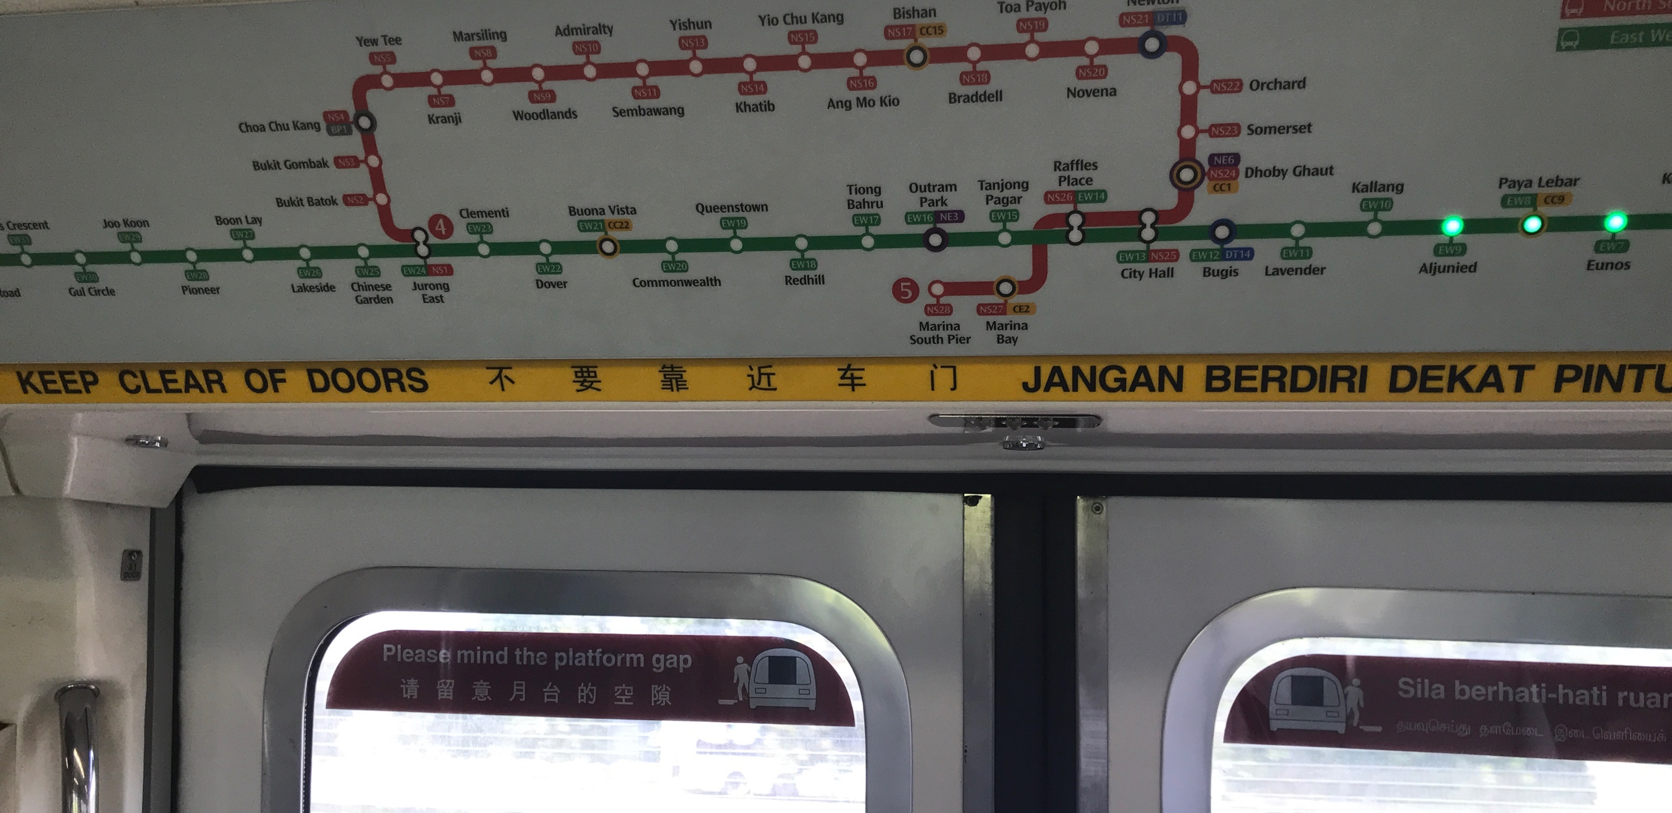
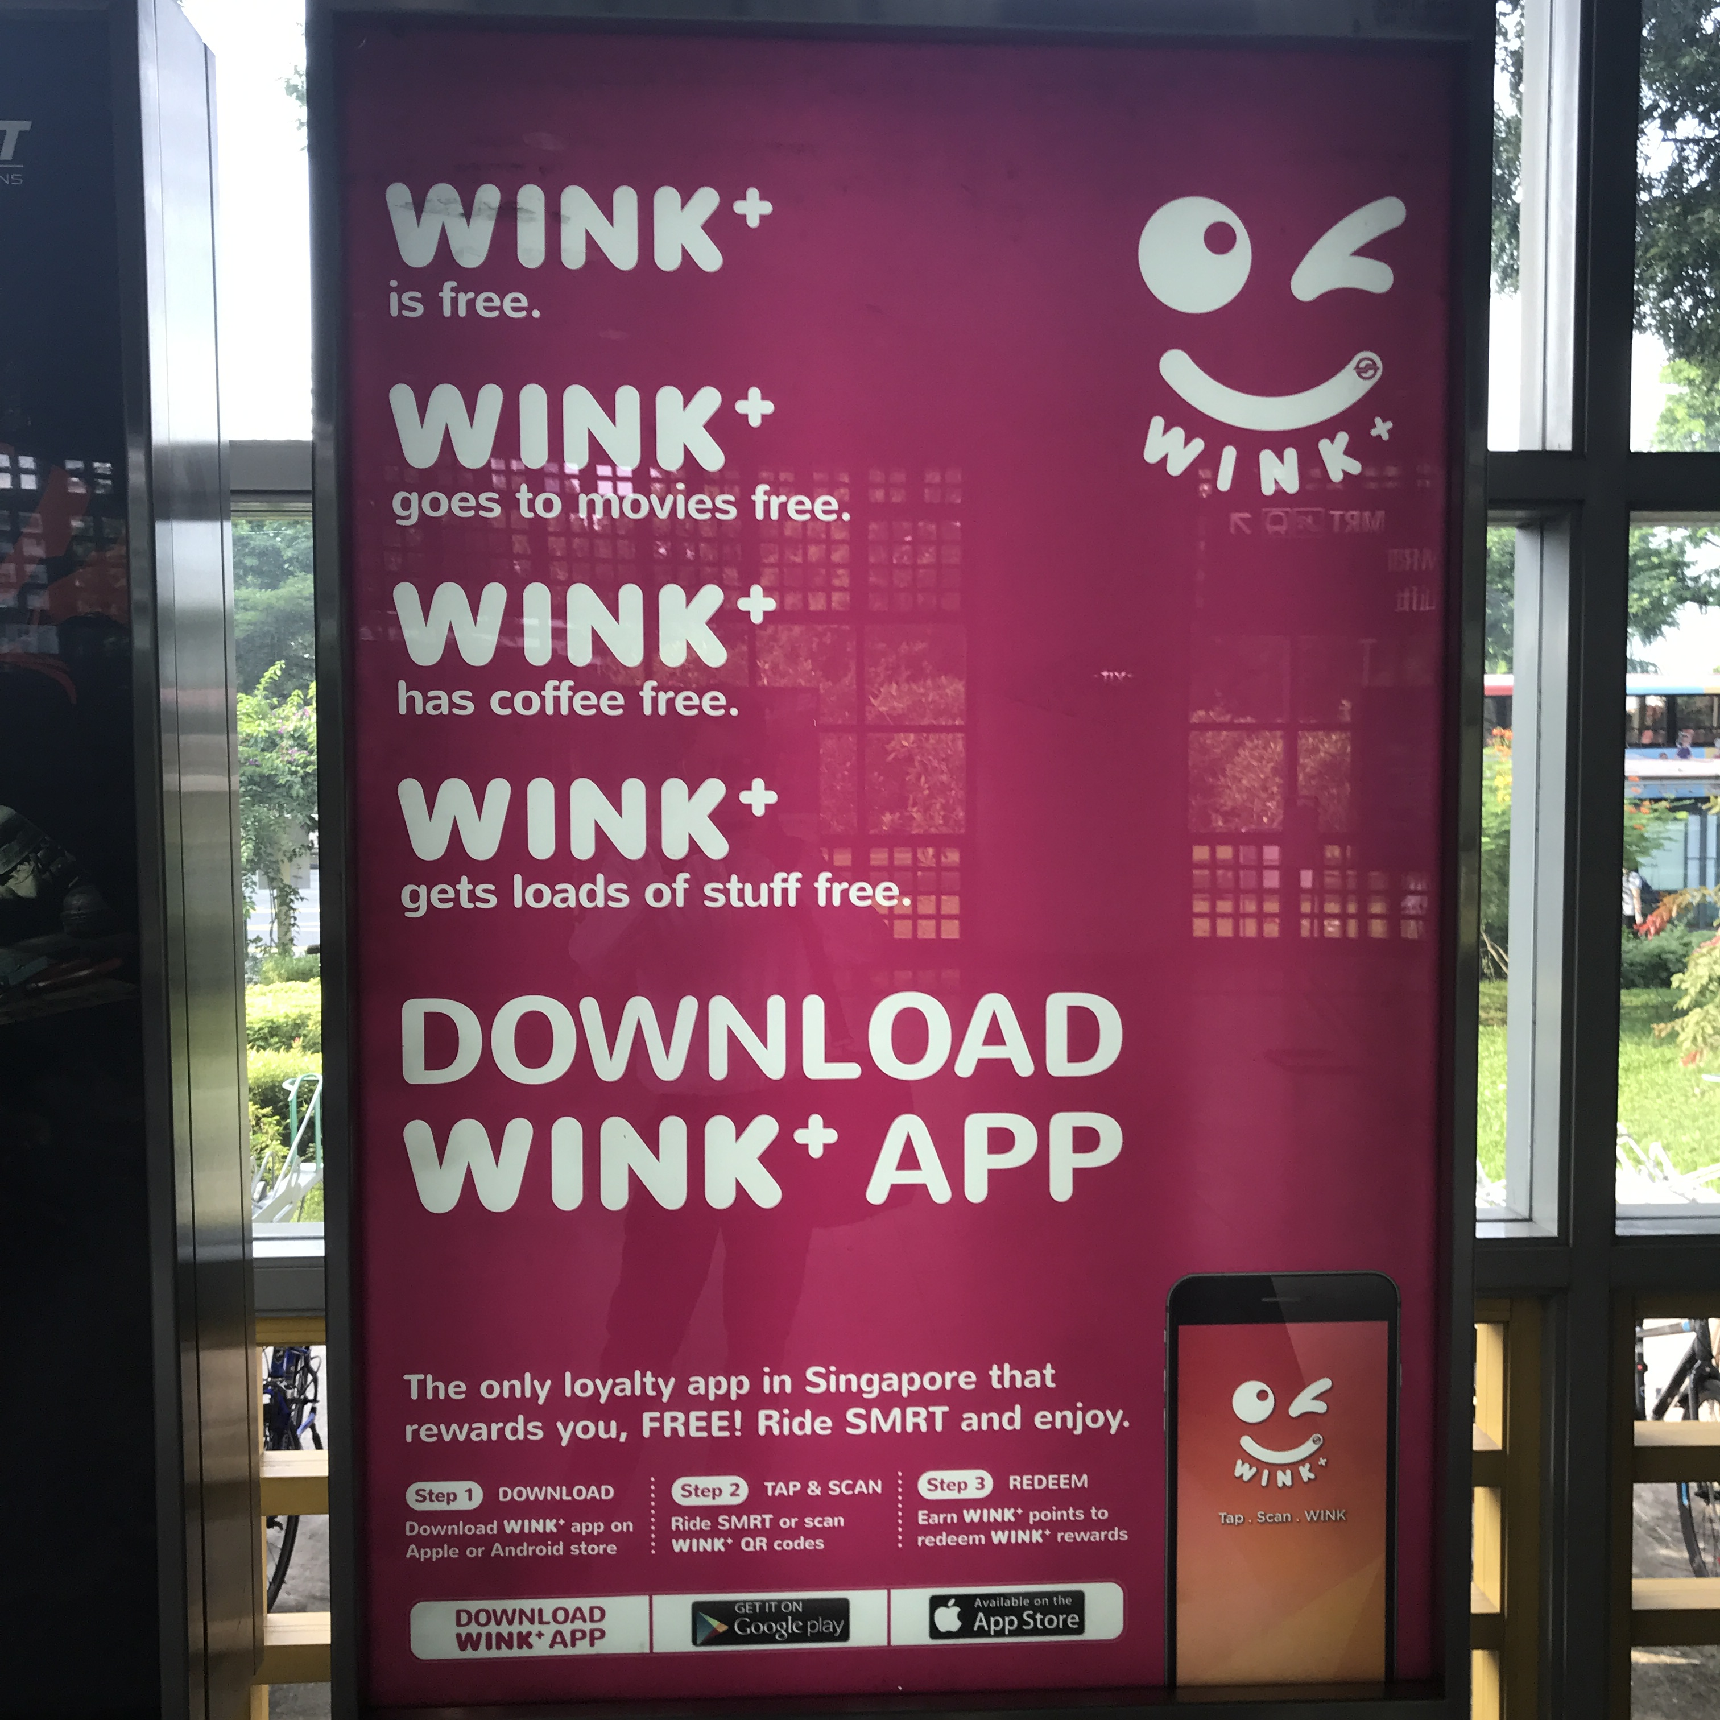
Picture 1: Warning on interior of MRT Train

Picture 2: Wink+ Advertisement in MRT Station

