Simón Crespo Pérez
July 7th, 2019
Journal #1: Llapingacho
Paragraph #1: Why do you like this dish and what is the significance of it for you?
Llapingacho, which consists of fried cheese potato pancakes served with rice, sausage, avocado (or salad), fried eggs, fried plantains, and a special peanut sauce, is a dish that is important to me since it represents my cultural and family background. It represents my cultural background because it is originally from Ecuador’s Andes Region, my home country, and it represents my family background because it has been a favorite of my family all the way from previous generations to mine. I remember since I was a little child that we will meet with my whole extended family in the house of my grandmother every Sunday. We would proceed to engage in highly entertaining conversations until around 2:30PM when lunch was served. The menu variated each Sunday between yapingacho and ceviche, which is another delicious dish from my small part of the world. The way the dish is made in my grandmother’s house was so good, we never got tired of it. Sadly, she passed away, but I will try to find her original recipe and frame it because every time I eat a yapingacho I am reminded of her. It would be amazing to hang her hand-written recipe in my room. Clearly, llapingacho brings taste to my mouth, and nostalgia to my heart.
Paragraph #2: Include a photo of the dish and a photo of yourself or family. Please provide the source of the photos if you don’t own the copyright.
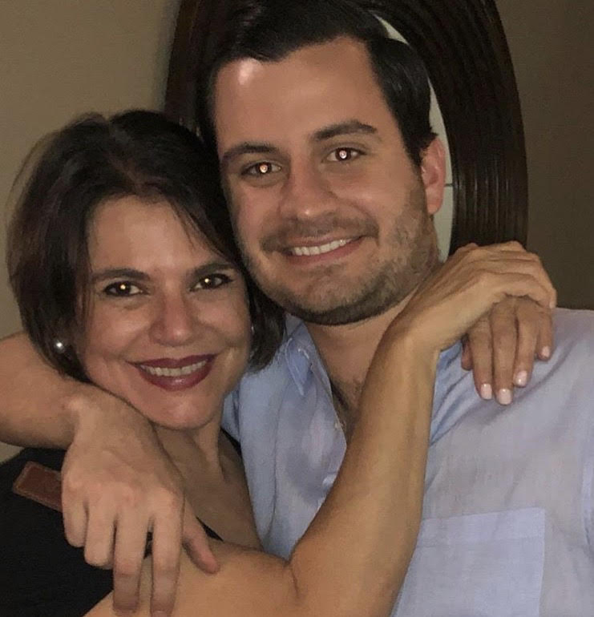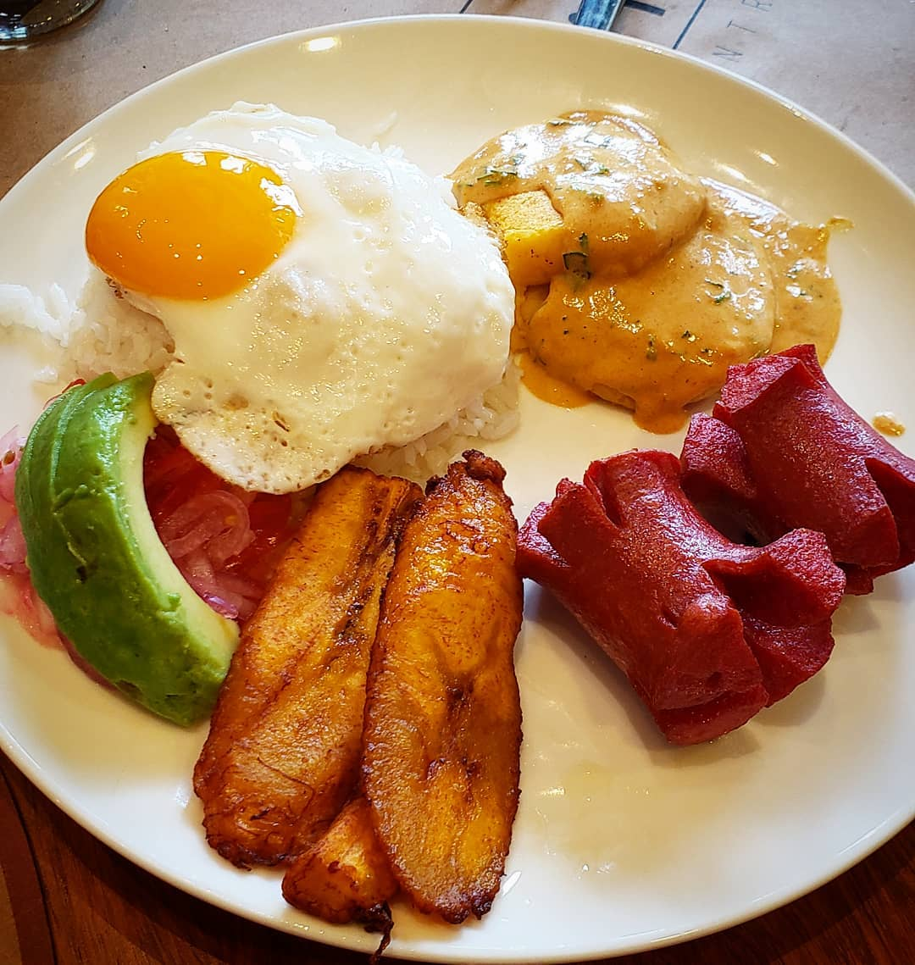
llapingacho
https://tinyurl.com/y2hs8zrl
My Mom and I. My dad had a car accident 10 years ago and was left in a coma. He enjoyed his llapingacho too even though he consumed it less due to cholesterol problems.

Paragraph #3: Research the history, culture, or geographic information relevant to the dish.
For this part of the assignment, I contacted a family friend and also llapingacho lover, well-known Ecuadorian historian, José A. Gómez-Iturralde. According to him, the plate is original from Ambato, Ecuador, which is a city in Ecuador’s Andes Region, one of the four regions of Ecuador together with Galapagos Islands, Ecuador’s Coastal Region, and Ecuador’s Amazon Region. It originated in Ambato, or as he calls it the Garden of Ecuador due to its variety of species. All elements of the llapingacho can be found in this region. According to him, it has so many species that there is a Festival of Fruits and Flowers every year to commemorate the anniversary of the earthquake that destroyed the city in the late 1940’s and killed around 6000 citizens. It originated there thanks to the Native Ecuadorians of the region, who made the fried cheese potato pancakes component of the dish even before Columbus arrived to America. The name of the dish comes from the Native Ecuadorian word llapin, which means mashed, just like the fried cheese potato pancakes.

Recipe (Not Included in Page Count): I don’t cook, but I found the best recipe in the following website, https://www.myrecipes.com/recipe/llapingachos-ecuatorianos-ecuadorean-potato-and-cheese-patties.

