The Commonplace Book Project

Commonplace Book

During the sixteenth and seventeenth centuries, one of the most important tools of a writer was a commonplace book. According to the Oxford English Dictionary, a commonplace book is “a book in which 'commonplaces' or passages important for reference were collected, usually under general heads; hence, a book in which one records passages or matters to be especially remembered or referred to, with or without arrangement.” Commonplace books were something like diaries or journals, but instead of recording the events of the day or one’s emotions or feelings, they served as places to record quotations or summaries of information that one might use in future writings, along with reflections on those quotations and information. Famous people who have kept CPBs included Francis Bacon, John Milton (our subject this semester), Thomas Jefferson (who included Milton in his CPB), Mark Twain, and Virginia Woolf.

John Hancock’s Commonplace Book:

"[L]et us take down one of those old notebooks which we have all, at one time or another, had a passion for beginning. Most of the pages are blank, it is true; but at the beginning we shall find a certain number very beautifully covered with a strikingly legible hand-writing. Here we have written down the names of great writers in their order of merit; here we have copied out fine passages from the classics; here are lists of books to be read; and here, most interesting of all, lists of books that have actually been read,…."

Virginia Woolf
“Granite and Rainbow” (1958)
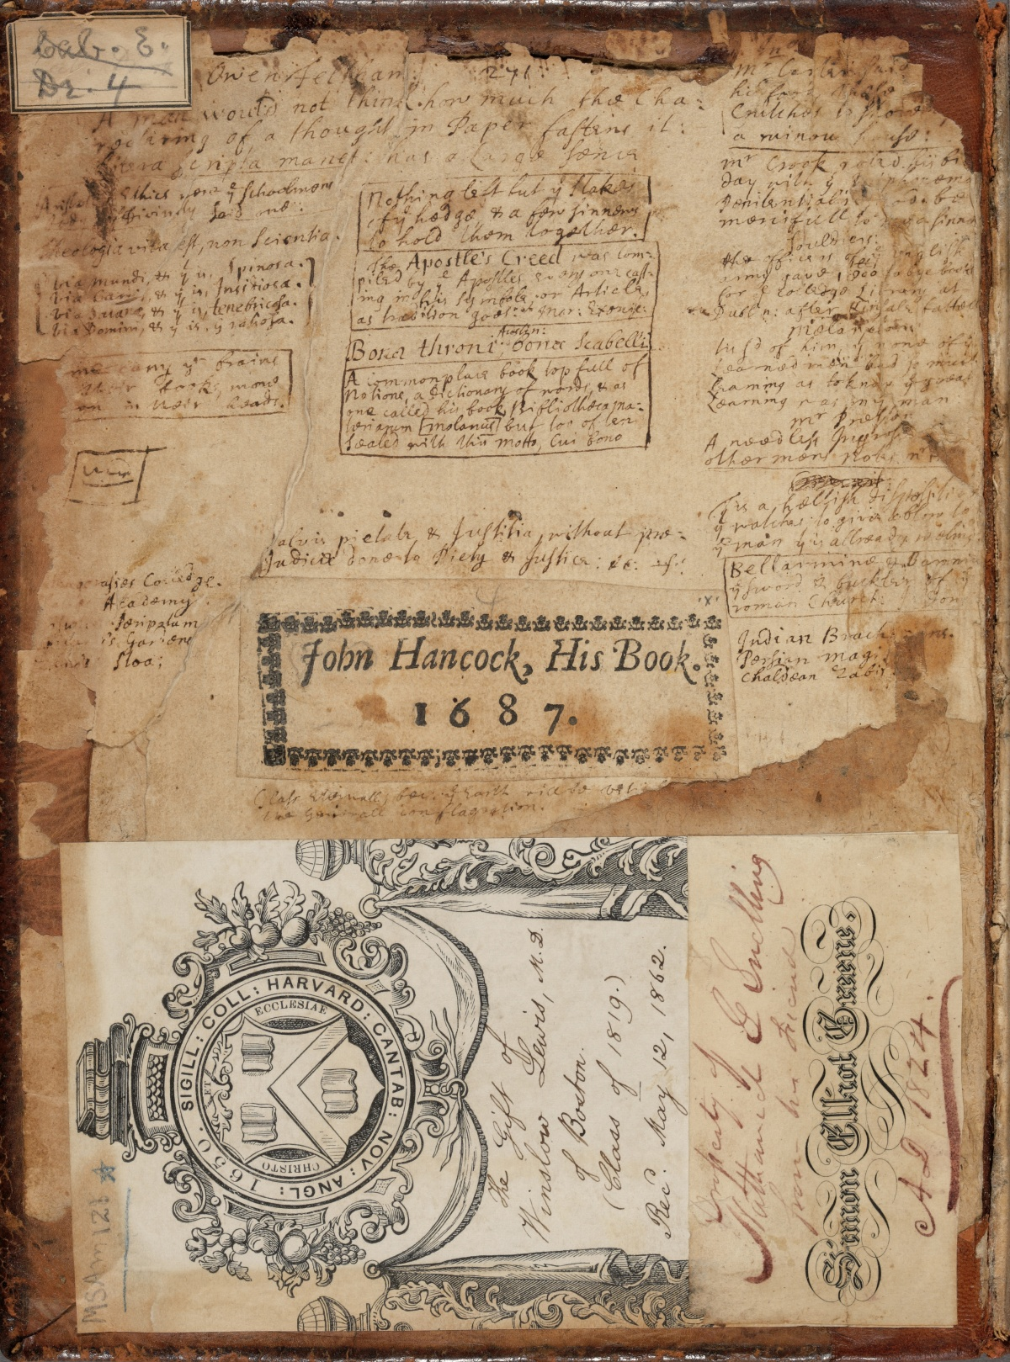
Hancock, John. Commonplace Book. 1687. Harvard University.
Take Note. Center for Hellenic Studies. Web. 28 Dec. 2015.

Robert Darnton writes in the New York Review of Books (Dec. 21, 2000) that commonplace books
…involved a special way of taking in the printed word. Unlike modern readers, who follow the flow of a narrative from beginning to end, early modern Englishmen read in fits and starts and jumped from book to book. They broke texts into fragments and assembled them into new patterns by transcribing them in different sections of their notebooks. Then they reread the copies and rearranged the patterns while adding more excerpts. Reading and writing were therefore inseparable activities. They belonged to a continuous effort to make sense of things, for the world was full of signs: you could read your way through it; and by keeping an account of your readings, you made a book of your own, one stamped with your personality. (47.20)

Oddly enough, this pattern of taking in bits and pieces of information and recombining them parallels the patterns of reading practiced by many in the age of the Internet—from Evernote to fan sites to blogs, commonplace practices are alive and well.

For this assignment, choose at least twelve themes or topics to track in your commonplace book, but you can trace as many as you want. Each theme should have at least five quotations, for a minimum of 60 quotations. Here are some possible themes to choose from (you can of course add your own):

failure
tyranny
reason
freedom
nature
love
Eyesight/seeing
revenge
war
pride
God
gender
dignity
language
ambition
error/Mistakes
knowledge
justice
Imagination

Commonplace Book Frequently Asked Questions:

- What size should my commonplace book be?
  - Well, I recommend something that is relatively small—not a full 8.5x11, but perhaps 5x9, or even smaller.
- Do I have to use lined paper?
  - No! Some people like blank paper, others like graph paper.
- Does it have to have a particular kind of binding?
  - It’s your choice. Some people like spiral bound notebooks. Others like hard or paperback bound books. Some people like mini 3-ring binders, so they can add pages and move them around. Some people even keep their commonplaces in accordion books, where the pages are all connected and fold out of the book.
- Does my handwriting need to be legible?
  - Yes—at least to yourself.
- Can I include quotations from things other than Milton in my commonplace book?
  - Please do!
- Can I include images?
  - Sure! I sometimes print and glue images into mine. You can also sketch and draw.
- Do I need to cite?
  - To a certain extent, yes. Include page numbers and the author and source.
- Can I include my own ideas and thoughts?
  - Yes, absolutely! Some people like to record their own thoughts in a different color than the rest of the text, or run it in different directions, so that it’s clear that they aren’t quotations.

