January 15, 2021

Dear college students at Burruss,

Greetings on this first day of your new college class. For the next 9 weeks, I will be your writing professor, guiding you through a course on “Critical Thinking and Writing” just like I teach at Emory University, and like I taught at Georgia Tech before I came to Emory. After me, you will have Dr. Claiborne from Morehouse College teaching Literature, and then three more professors each teaching nine weeks of 45 weeks of History, Art, and Philosophy. Once you complete the five sections, you will receive six credit hours from Bard College. Bard is an elite college in New York and your Bard College transcript will transfer to any other college, such as Georgia State University. I am honored to be your first accredited professor.

I understand that you may be skeptical: is this “real”? I’m not there in person because of the pandemic, but I assure you that you are part of an accredited, rigorous, intellectual program. More than 70 college faculty form a consortium teaching inside Georgia’s prisons (Phillips State, Whitworth Women’s, Metro Reentry, and Burruss Correctional) in addition to their regular teaching jobs at Emory, Georgia Tech, UGA, Morehouse College, Kennesaw State, Georgia State, and others). We have been teaching inside prisons since 2008. Last year, the GA governor awarded our nonprofit called “Common Good Atlanta” the Governor’s Award in the Humanities, for “significant contribution to Georgia’s civic and cultural vitality.” Many of our alumni, now released from prison and finishing their college degrees in Atlanta, celebrated with us.

So how will it work? Well, until the quarantine ends, you will receive this blue portfolio every week with a new reading, a new assignment, and feedback on your last assignment. And every week, you will put your completed assignment in the plastic portfolio and I will come pick it up. This packet exchange will continue until we are allowed to return and teach in person. It will be challenging that you can’t ask me questions or clarify things in person, but please know that I and all your professors will work with you generously and enthusiastically. We want you to succeed.

What’s in today’s packet? A lot! Here is a list:
- Your course syllabus, “Critical Thinking and Writing”
- A “student contract” to sign and return next week
- A Manilla folder with the first reading, William Zinsser’s On Writing Well
- An assignment sheet explaining the two kinds of writing you will do for the first nine weeks: an informal, one-page “reflection” and a more structured “rhetorical précis” (pronounced “pray-see”). The assignment sheet explains exactly how to do both kinds of writing, but I will also give you feedback. Don’t worry about “messing up.” That
- An explanation of how to do “peer review.” This isn’t due for a while, so we’ll get to that later. But it’s important that you learn how to give and receive your peers feedback, instead of just relying on a professor.
- Some paper and some sticky notes, which are just for your own use

What do you do next? Read everything, then complete your first assignment, a one-page “Reflection” on the first reading, chapters from On Writing Well. The assignment explains what a “reflection” is. Put your reflection back in the blue plastic folder, and I will pick it up on Friday, January 22, when I drop off you next reading. You can also include any questions or notes for me in the folder.

Who am I, and why am I doing this? I’m a college professor who teaches writing and literature at Emory University. For the last 13 years, I’ve also been volunteering in prisons, because I believe that everyone benefits when there is broad access to higher education. I’ve taught more than 3,000 hours inside prisons, mainly at Phillips State Prison. I began at Burruss last January. We were interrupted in March because of the pandemic, but invented this packet system as a way to continue. This packet system is hard for all of us, but I’m impressed at how well the men at Burruss have done. Please know that neither I nor any of your other professors have an “agenda,” except that we want to extend the knowledge and empowerment of our college classes into prisons, because we believe in you.

If you have problems, Chaplain Dunlap said she can reach out to me. Also, go to Larry Black,
I wish you guys so much more than luck. Always remember your minds are free.

Kind wishes,
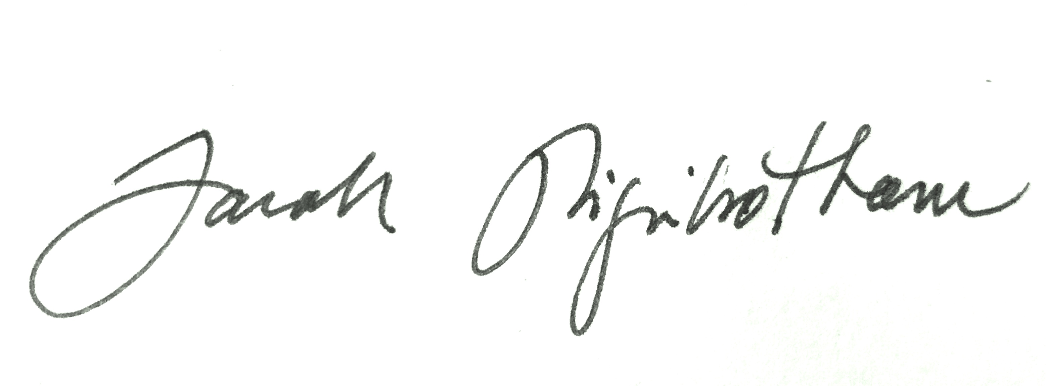
Dr. Sarah Higinbotham

