January 28, 2021

Read this First!

Dear college students at Burruss,

It’s week 3! What a genuine pleasure to read your first work, reflections on William Zinsser’s classic book on writing. Your perspectives on Zinsser varied with your personalities, intellectual styles, and your opinions on writing. I actually ordered his complete book for each of you, and will send it in a subsequent packet when the books arrive.

While we can’t be together in the classroom, here are quotes from other students, so you can get a sense of your peers’ reactions to Zinsser’s book:

“The essence of your message is buried under all those excess words.” --Austin
“Listen, I write the way I speak. If I clutter, embellish, garnish, or even add some jargon, then it’s because I’m speaking to you. My hand is my mouth while my tongue is this pen.” –Larry
“I had to throw away the concept that I just had to be like so many other authors and use all of these big, complicated words and copy their style and method.” – Elijah
“Since I look at life from an entirely different eye (I), everything is mathematical.” – Drawn
“I want to throw my toupee on and insert these exorbitant words that I don’t know the definition of. Zinsser helped me see that writing isn’t always about impressing everyone who reads your work, but knowing it’s yours when they read it.” – Mack
“A question I have is when should one put down one’s pen and consider the work finished?” – Buford
“As Americans, our use of the English language is full of shortcuts and is littered with laziness.” -- Anthony
“This guy William Zinsser is like a really clear mirror that makes all your smallest imperfections visible. I hate it, and I love it. After about ten pages, I started fishing out half-written, and long-forgotten stories, articles, and poems I had buried and started correcting, simplifying, and tinkering. It was painful and exhilarating.” --Xavier
“As a growing musician, I was told my style was specific. Unique. Writing should be the same. Each of us has something unique to contribute to artistic expression.” – Ryan
“He also has made it known that this clutter in people’s writing also affects the ‘flow,’ or how it sounds in the reader’s mind. … I realized how much flow matters in all writing. I now see that mediocrity in books, short stories, etc. can be blamed potentially on bad flow: If a reader has to re-read every other sentence to understand it, then most likely they will ‘find something new,’ as Zinsser stated.” – Kaden
“The views we get to see from these two writers show that many people have different outlooks on writing, some write because they have to, some write to relax and record their thoughts.” – Devarius
“Like it says in the passage, ‘Not only are those first paragraphs impersonal; they don’t say anything.’” – Zachary

In each of your reflections on William Zinsser, I saw keen minds at work.

I hope it was clear how to write your assignment for this week, a précis on professor Wayne C. Booth’s essay, “Boring from Within: The Art of the Freshman Essay.” I look forward to reading them.

For this week, you will read two very different things, but both more about philosophy than the process of writing. The first is Plato’s “Allegory of the Cave,” written as part of his longer book The Republic. Plato lived in about 400 BCE (“Before the Common Era,” what we used to call BC, or “Before Christ”). Plato was interested in how to form a perfect society, and that’s what his book is about. He includes this “allegory” – a story that tells a deeper meaning – inside the book. It’s very famous and college students often read it.

David Foster Wallace was a very famous writer, and the essay he wrote on a Lobster Festival is also something many students read their first year in college.

Instead of an open reflection, I’ve created a sort of guided-reflection for you to complete, stapled to the readings.

Don’t be afraid of making mistakes. They are how we learn. As long as you keep doing the work, you will succeed! The only way to fail is to stop trying.

You have two assignments this week: a guided reflection on Plato’s “Allegory of the Cave.” And a sheet to complete on Wallace’s on “Consider the Lobster.” I will collect your assignment sheets on on February 4. And you’ll also get my feedback on your Booth assignments. Never hesitate to send me any questions. And may we all be vaccinated soon, so we can get back to in-person classes. I look forward to walking into Visitation and having an in-person class!

I wish you guys so much more than luck. Always remember your minds are free.

Kind wishes,
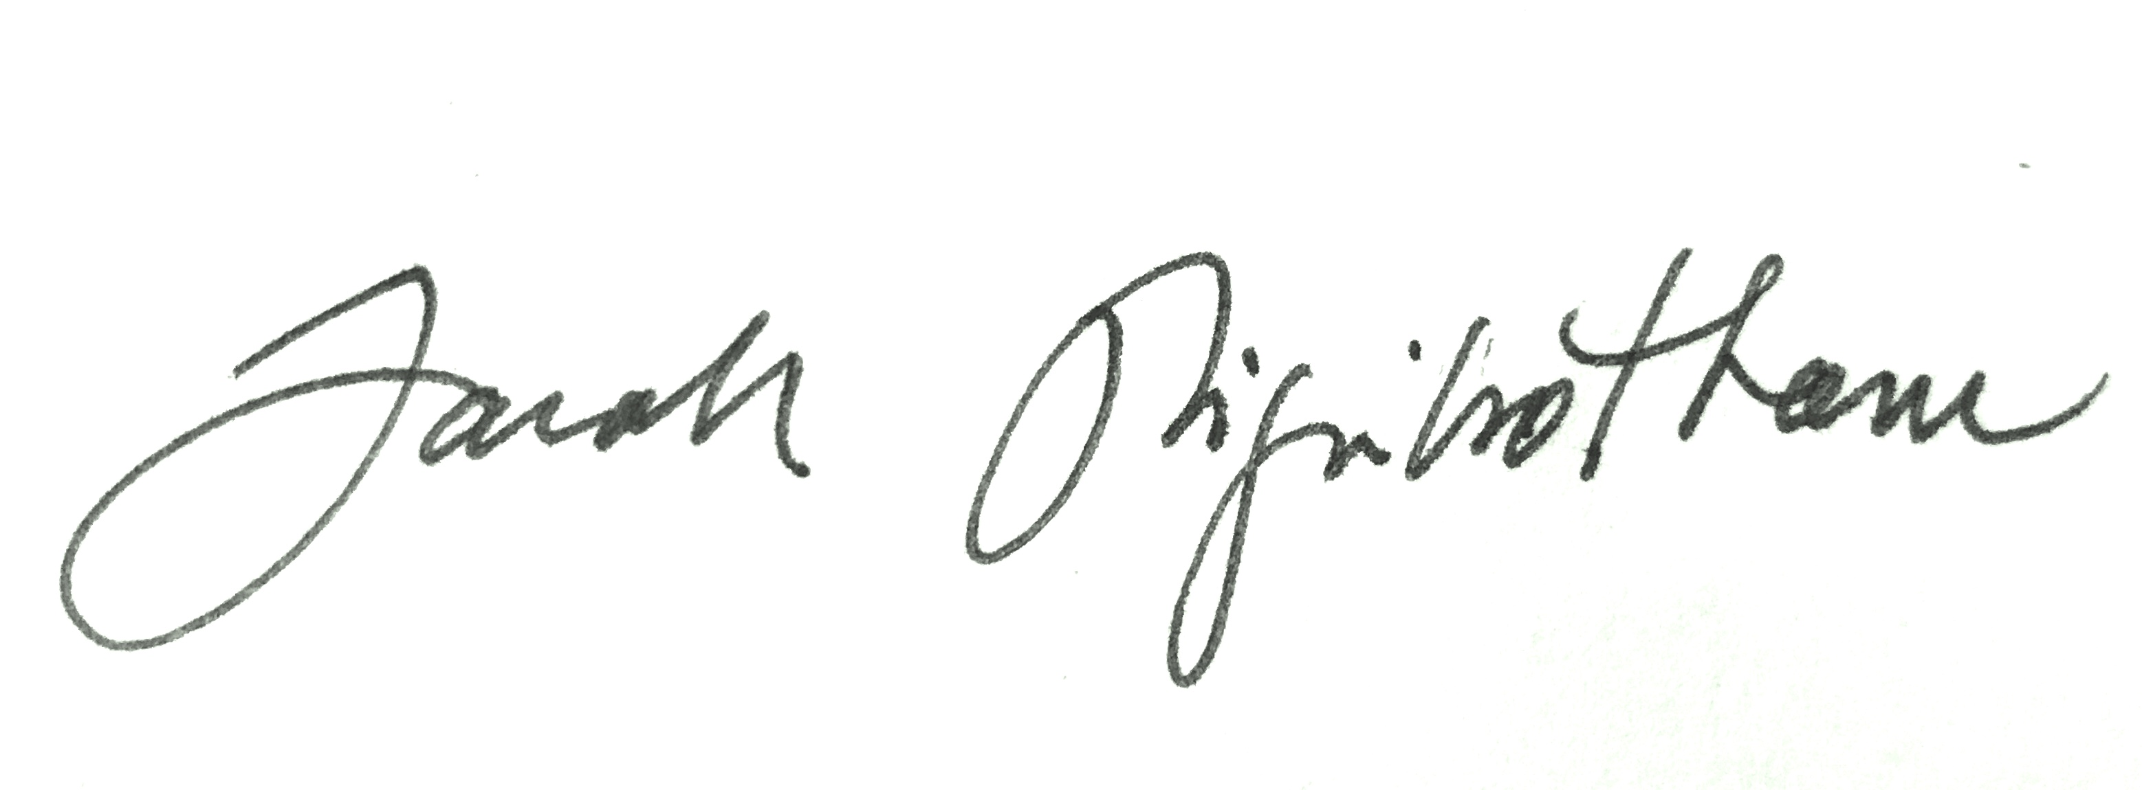
Dr. Sarah Higinbotham
ps: sometimes I put little extra things in the packet, to help mitigate the fact that we don’t get to have fun, in-person class discussions. This time it’s a literary postcard.

