February 5, 2021

Dear Austin, Larry, Elijah, Drawn, Mack, Buford, Anthony, Xavier, Ryan, Kaden, Devarius, and Zach,

Greetings on the 4th week of class to you scholars! I’m grateful that I can now envision you all after our Zoom session on Wednesday, even though I know it was hard for me to hear you. Still, I could see real, live people sitting in the class, and I hope it helped you to see that I’m a real person too, behind these stacks of paper you receive in blue portfolios.

I need to tell you all that your rhetorical précis assignments are far more advanced than I usually see in freshman writing classes. It might seem easy – “write a highly-structured four-sentence paragraph about an article” – but it’s actually really, really hard to be concise and to write within a structure. Even without live instruction, you excelled. You should feel deeply gratified by how you are doing.

Now for my confession: yes, I am aware that asking you to write a rigid, short summary of a long article about how writing professors assign uninspiring assignments was perhaps the ultimate irony! Booth’s famous essay (as you all so eloquently stated in your précis) centers on how writing professors must seek to engage their students with ideas that will ignite and enliven their writing. When the topic bores the writer, the writing will often be… boring. Ideally, I could be there in class with you and could learn more about what animates your minds, things like aeronautics (Anthony), working out (Kaden), auto body repair (Buford), cinematography (Mack), philosophical correlations and contrasts (Drawn), engineering (Austin), history (Elijah), entrepreneurship (Xavier), obtaining knowledge (Devarius), music (Ryan), sports (Zach), and Shakespeare (Larry). Or wait, Larry, am I wrong about your passion for William Shakespeare..?

But here’s the truth: not all assignments and readings will naturally interest you. And your professors will naturally gravitate toward the ideas and texts that enliven them. So sometimes you will have to find ways to make your writing come alive – that could be by connecting your own purposes passions to the assignment. And quite honestly, I think this is one of the many things that college teaches you: how to just keep working, even when the work wears you out.

All that said, the two readings you completed for last week’s packet (Plato and David Foster Wallace) shifted away from the concept of writing itself and toward “philosophy,” which is the study of knowledge and thinking. You will take an entire 10-week course in philosophy, so I wanted to give you all a preview of the kinds of things you will think about: Plato on the nature of seeking enlightenment and truth, and Wallace on how to think about complex and uncomfortable truths, such as whether our pleasure causes others pain, and whether we have an obligation to “consider” that. I could sense that some of you found his essay frustrating. You are not alone. But even as someone who eats meat myself, I’ve been re-reading the essay for many years and find it important to remind myself to think about the questions Wallace raises. This is one of the things that the study of philosophy does for us. I’m including someone else’s review essay on “Consider the Lobster” that discusses the essay, as I wish we could do live in class together.

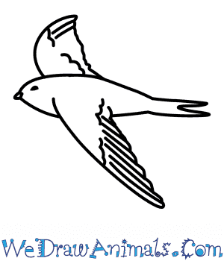
For this week, you will read a shorter essay in the sub-genre of philosophy known as “nature writing.” It’s an essay about the behaviors of a certain bird, the swift, a picture of which I include here to the left. But of course the essay is not really about a bird, or not only about a bird, in the same way that Plato is not actually talking about a cave, and Wallace is writing about more than lobsters. I hope when reading Helen Macdonald’s philosophical reflection on flying that you sense how writers often talk about abstract and complex moral ideas through tangible, physical things like caves, lobsters, and birds. In full disclosure, I chose “Vesper Flights” because it’s been a tremendously important essay to me over the last few months as I contemplate our sterile, isolated lives amidst this ongoing pandemic.

Don’t be afraid of writing “wrong.” Keep seeking your own voice, striving to make your writing sound like you. One way to do this is to read what you’ve written out loud, and allowing your “ear” to help you edit. I read everything I write out loud (including this letter) so that as much as possible, what I write sounds like a real person. If you have someone you can read your writing out loud to (even an imaginary person), you will begin to hear your own voice emerging and can edit accordingly.

I’ll collect your reflection on “Vesper Flights” on Friday, February 12.

I wish you guys so much more than luck. Always remember your minds are free.

Kind wishes,
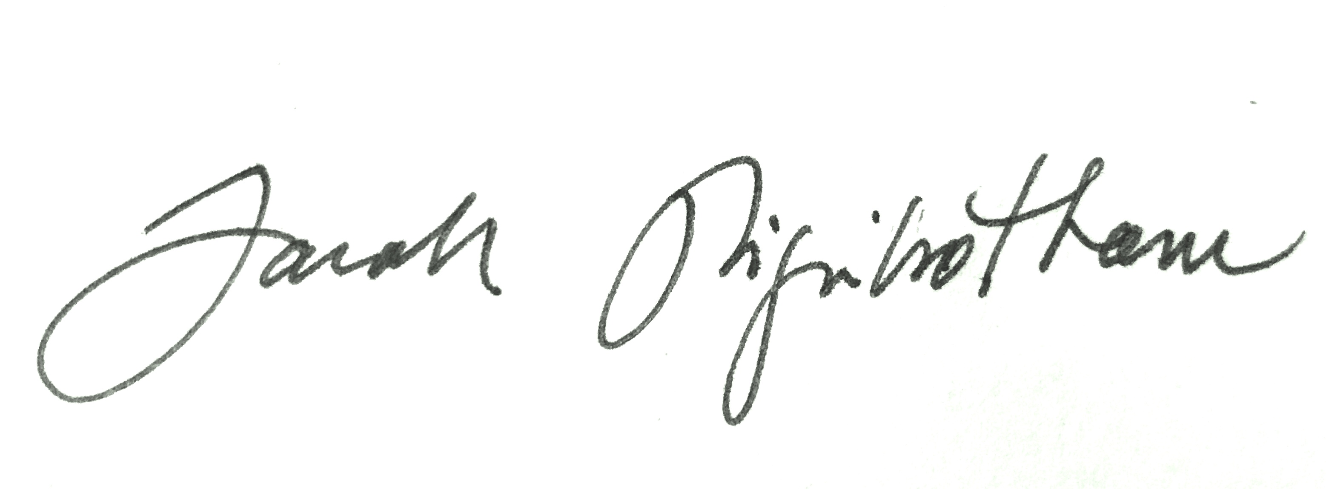
Dr. Sarah Higinbotham
ps: these sticky tabs are just to mark pages and ideas that you want to return to. I hardly own a book without about a dozen sticky tabs amidst the pages, waving like tiny little flags and representing ideas that I think are important.
pss: I keep meaning to point out what is evident, that I have three undergraduate students who are sending you “peer review” on each assignment: Ola, Aditi, and Lola. They have all taken my writing class at Emory. Next week, they will send you something they have written to get your peer review.

