Wassily Kandinsky

Wassily (pronounced “Vassily”) Kandinsky (pronounced “can-DIN-ski”)
4 December 1866 – 13 December 1944
A Russian painter an art theorist, Kandinsky is credited with being the pioneer of abstract art.

Vasily Kandinsky was born on December 16, 1866, in Moscow. From 1886 through 1892 he studied law and economics at the University of Moscow, where he lectured after graduation. In 1896 he declined a teaching position in order to study art in Munich with Anton Azbe from 1897 to 1899 and at the Kunstakademie with Franz von Stuck in 1900. Kandinsky taught in 1901–03 at the art school of the Phalanx, a group he cofounded in Munich. One of his students, Gabriele Münter, would be his companion until 1914. In 1902 Kandinsky exhibited for the first time with the Berlin Secession and produced his first woodcuts. In 1903 and 1904 he began his travels in Italy, the Netherlands, and North Africa and his visits to Russia. He showed at the Salon d’Automne in Paris from 1904.
In 1909 Kandinsky was elected president of the newly founded Neue Künstlervereinigung München (NKVM). The group’s first show took place at Heinrich Thannhauser’s Moderne Galerie in Munich in 1909. In 1911 Kandinsky and Franz Marc began to make plans for Der Blaue Reiter Almanac, although the publication would not appear until the following year. Kandinsky’s On the Spiritual in Art was published in December 1911. He and Marc withdrew from the NKVM in that month, and shortly thereafter the Blaue Reiter group’s first exhibition was held at the Moderne Galerie. In 1912 the second Blaue Reiter show was held at the Galerie Hans Goltz, Munich. Kandinsky’s first solo show was held at Der Sturm gallery in Berlin in 1912. In 1913 one of his works was included in the Armory Show in New York and the Erste deutsche Herbstsalon at the Der Sturm gallery in Berlin. Kandinsky lived in Russia from 1914 to 1921, principally in Moscow, where he held a position at the People’s Commissariat of Education.
Kandinsky began teaching at the Bauhaus in Weimar in 1922. In 1923 he was given his first solo show in New York by the Société Anonyme, of which he became vice-president. Lyonel Feininger, Alexej Jawlensky, Kandinsky, and Paul Klee made up the Blaue Vier (Blue Four) group, formed in 1924. He moved with the Bauhaus to Dessau in 1925 and became a German citizen in 1928. The Nazi government closed the Bauhaus in 1933 and later that year Kandinsky settled in Neuilly-sur-Seine, near Paris; he acquired French citizenship in 1939. Fifty-seven of his works were confiscated by the Nazis in the 1937 purge of “degenerate art.” Kandinsky died on December 13, 1944, in Neuilly.

Three of his paintings follow:
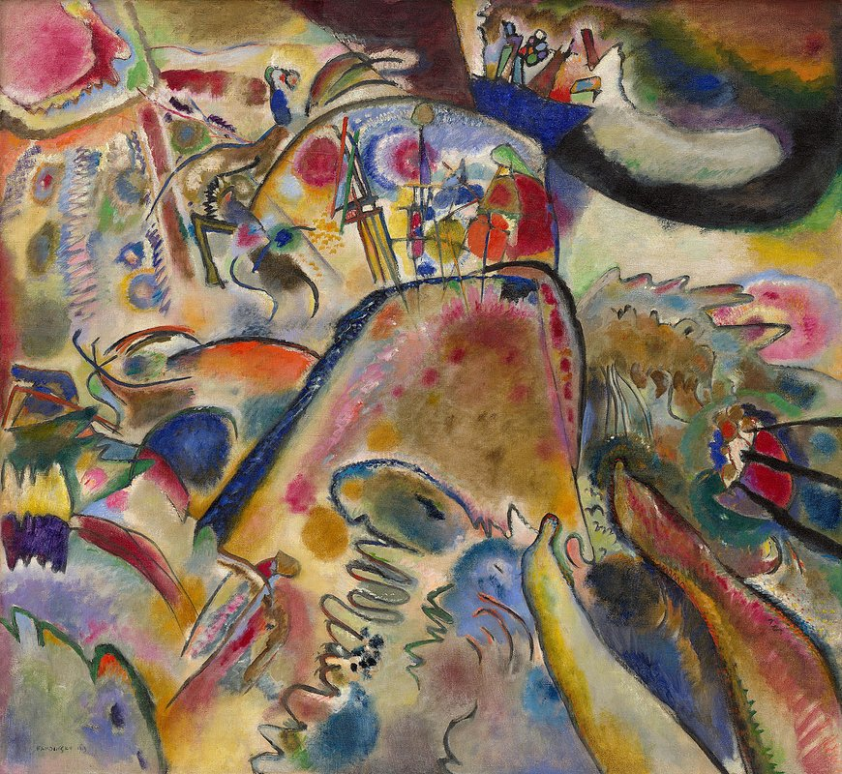

“Small Pleasures”
With its undulating colored ovals traversed by animated brushstrokes, Black Lines is among the first of Kandinsky’s truly nonobjective paintings. The network of thin, agitated lines indicates a graphic, two-dimensional sensibility, while the floating, vibrantly hued forms suggest various spatial depths.
By 1913 Kandinsky’s aesthetic theories and aspirations were well developed. He valued painterly abstraction as the most effective stylistic means through which to reveal hidden aspects of the empirical world, express subjective realities, aspire to the metaphysical, and offer a regenerative vision of the future. Kandinsky wanted the evocative power of carefully chosen and dynamically interrelated colors, shapes, and lines to elicit specific responses from viewers of his canvases. The inner vision of an artist, he believed, could thereby be translated into a universally accessible statement.
He realized, however, that it would be necessary to develop such a style slowly in order to foster public acceptance and comprehension. Therefore, in most of his work from this period he retained fragments of recognizable imagery. “We are still firmly bound to the outward appearance of nature and must draw forms from it,” he wrote in his essay “Picture with the White Edge,” but suggested that there existed a hidden pictorial construction that would “emerge unnoticed from the picture and [would thus be] less suited to the eye than the soul.” Painting with White Border, for instance, was explained by Kandinsky as a response to “those . . . extremely powerful impressions I had experienced in Moscow—or more correctly, of Moscow itself.” To illustrate the spirit of the city, Kandinsky included an extremely abbreviated image of a Russian troika driven by a trio of horses (the three diagonal black lines in the upper-left portion of the canvas). The mass of swirling colors and lines in the center has been convincingly interpreted as the figure of a lance-bearing St. George on horseback, an allusion to Moscow’s tsarist tradition (the state seal of Peter the Great included an emblem of the saint). Small Pleasures is filled with veiled imagery of the Last Judgment, as in many of his paintings, but its title suggests other readings. In an essay on the work, Kandinsky wrote that his goal “was to let . . . [himself] go and scatter a heap of small pleasures upon the canvas.”

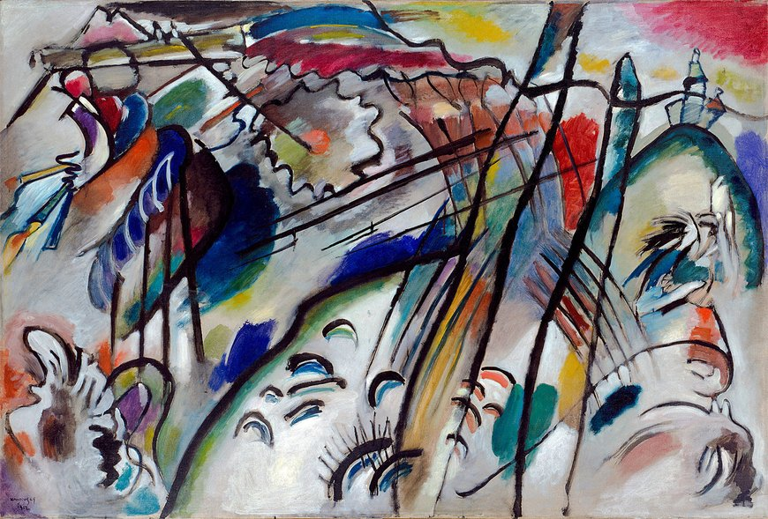

“Improvisation 28”
Vasily Kandinsky’s use of the horse-and-rider motif symbolized his crusade against conventional aesthetic values and his dream of a better, more spiritual future through the transformative powers of art. The rider is featured in many woodcuts, temperas, and oils, from its first appearance in the artist’s folk-inspired paintings, executed in his native Russia at the turn of the century, to his abstracted landscapes made in Munich during the early 1910s. The horseman was also incorporated into the cover designs for Kandinsky’s theoretical manifesto of 1911, On the Spiritual in Art, and the contemporaneous Blue Rider Almanac, which he coedited with Franz Marc.
In 1909, the year he completed Blue Mountain, Kandinsky painted no less than seven other canvases with images of riders. In that year his style became increasingly abstract and expressionistic and his thematic concerns shifted from the portrayal of natural events to apocalyptic narratives. By 1910 many of the artist’s abstract canvases shared a common literary source, the Revelation of Saint John the Divine; the rider came to signify the Horsemen of the Apocalypse, who will bring epic destruction after which the world will be redeemed. In both Sketch for Composition II and Improvisation 28 (second version) Kandinsky depicted—through highly schematized means—cataclysmic events on one side of the canvas and the paradise of spiritual salvation on the other. In the latter painting, for instance, images of a boat and waves (signaling the global deluge), a serpent, and, perhaps, cannons emerge on the left, while an embracing couple, shining sun, and celebratory candles appear on the right.

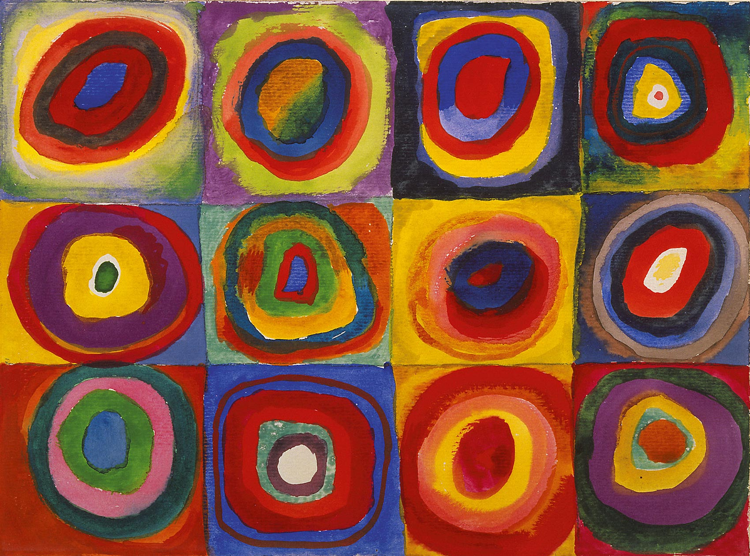

“Color Study. Squares with Concentric Circles”
1913
Watercolor, gouache and crayon on paper

9.4 × 12.4" (23.8 × 31.4 cm)

Squares with Concentric Circles (Farbstudie - Quadrate und konzentrische Ringe), perhaps, Kandinsky's most recognizable work, is not actually a full-fledged picture. This drawing is a small study on how different colour combinations are perceived that the painter used in his creative process as a support material.
For Kandinsky, colour meant more than just a visual component of a picture. Colour is its soul. In his books, he described his own perspective on how colours interacted with each other and with the spectator in detail and very poetically. Moreover, Kandinsky was a synaesthete, i.e. he could ‘hear colours’ and ‘see sounds.’

