Andrew Cahill
Dr. Higinbotham
English 1102 – HP4
1 November 2015
“This Is Not a King”
Henry V’s Chorus and the Treachery of Images
Apologetic writing is one of the weakest ways to begin communication, yet William Shakespeare---arguably one of the greatest voices in western literature---consciously chose to begin Henry V by apologizing for his humble stage and pathetic props. Critics still debate the role and effectiveness of this seemingly regretful Chorus, drawing inferences from historic precedent and context. From unabashed worshiper of Henry to enthusiastic, if apologetic, narrator of the play, the many interpretations of the Chorus constantly evolve but always return to the same point: an explanation for that awful introduction.
At the surface, the Chorus manifests as a shallow, one dimensional outline filled only by unending praise of the King. Glancing at the script, it appears that Shakespeare completely misused the archaic role of the Chorus. The Greeks invented the Chorus to set the scene and unify the time, place, and action of the development of the story, adding depth and insight to a relatively simplistic story line (“History of Theatre”). Shakespeare, however, should not need an exposition for his play, as his well-developed plots and general public knowledge of one of the greatest victories in English history make a narrator superfluous. George C. Odell, a Professor at Columbia of Dramatic Literature, calls Shakespeare’s work with the chorus “awkward and primitive” as Shakespeare shoves a dusty, unnecessary theatrical device into a perfectly good play (par. 3). And the dry text conveys that exact effect. However, this analysis discards an essential factor of the play; it was written not to be read off a page, but to have life breathed into it by an actor.
An actor’s interpretation of the Chorus gives depth to the character, creating insinuations that penetrate much deeper than just the written text. Lawrence Danson argues that in the introduction the Chorus is “mocking his own act with self-conscious exaggeration even as he earnestly enacts it. He’s sorry, but proud, and proud of being sorry in such an ingenious way” (28). By feigning modesty, Shakespeare captures the intrigue and love of the audience. This lines up even with modern culture – no one likes a braggart. The modesty does not broadly reference the inadequacy of the theater in general though, but more specifically the inability to convey the grandeur of the battle of Agincourt. The Chorus is awestruck by the magnificence of the subject of the play, which lends the air of a mythicized, epic persona that engulfs Henry (Royal par. 1). Both Royal and Danson’s ideas point to the larger matter of the historical significance of the play. Shakespeare attempts to describe England’s most valiant battle, and out of nationalistic respect for his country he acknowledges that he cannot fully do it justice on a simple stage. This combination of modesty and praise that the Chorus conveys endears the audience to the plot, increasing the effectiveness of the theater.
And yet the original purpose of the Chorus is still relatively muddled. Some literary critics attempt to clear away this confusion by analyzing the play from the context of Elizabethan England in which it was written. According to one Shakespearean scholar, it is unclear at what point the Chorus was even written since the part does not appear in the Quartos, first appearing in 1623 as part of the First Folio (Bednarz 486). In this context, addition of the Chorus was primarily for the benefit of the readers of the play, and not the viewers. By adding the Chorus, the editors could be attempting to preserve the history of England by giving context to future audiences. This clears Shakespeare’s name from the abnormally awkward addition of the Chorus, and yet there are many fragments of evidence that point out that the Chorus was always a part of the play (Bednarz 487). Anny Crunelle-Vanrigh claims that Shakespeare always had the Chorus written in as part of the play, but due to the charged atmosphere of fighting between the Irish and the English in 1599, any mention of them was cut by the editors and not allowed to be performed, thus leading to a highly fragmented chorus that was not published in full until the First Folio (355). In these conflicting historical accounts, the question still remains as to why Shakespeare would intentionally include an outdated and incendiary role in such a brilliantly crafted play. A possible explanation lies in Shakespeare’s portrayal of Henry V. Throughout the play Shakespeare references things unbecoming of a King including a lack of empathy to either his friends or captive enemies when he orders both dead without a second thought. By including the Chorus, Shakespeare may have simply been covering all of his spots to ensure that he did not end up being charged of treason and sentenced to death. However, even if he was primarily toning down the play, Shakespeare would never pass up a chance to layer in a bit more meaning. If Shakespeare was forced to create a redundant character whose content strictly comprised of propaganda, then the only thing left for him to manipulate would be the structure and placement of the Chorus.
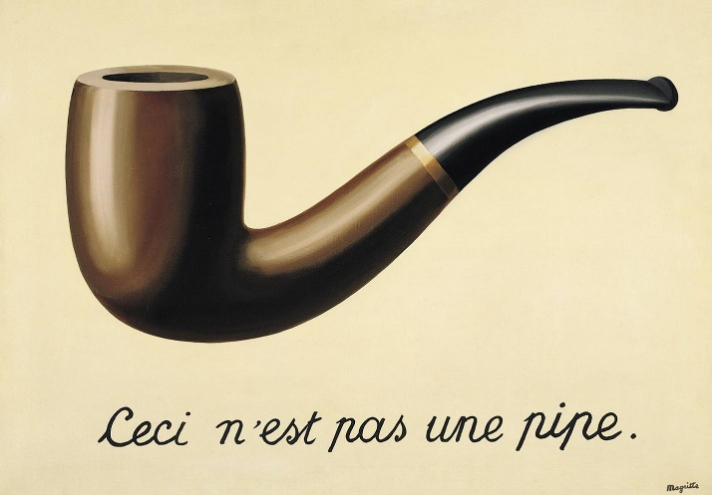
This structure and its implications are the most significant contribution of the Chorus to the text. The Chorus introduces each and every act, always praising the King’s accomplishments. Maurice Charney views the play as a whole as a presentation of Henry’s greatness, with the Chorus introducing five separate examples, one in each act (194). In a glowing, praiseful tone, the Chorus rattles off the heroic tales of the King. This introduction sets up an episodic structure like the epics of the time, giving strength to Henry’s almost god-like status. However, the Chorus can also be interpreted in a more pessimistic light, as it juxtaposes the ideal characteristics of the King with the harshness of his actual actions, such as when he threatens to rape all the daughters and kill the infants of Harfleur if the residents do not surrender (Gutierrez 160; Shakespeare 3.3.35–40). This shows a darker side of Shakespeare’s writing as he deceptively criticizes the apparent perfection of Henry. By drawing these parallels between the actual structure of the play and the content of the play, Shakespeare gives it a power that can only be found in a stage performance. He takes advantage of the segmented presentation and uses each to simultaneously exalt and critique the history of England. These similarities highlight the fact that “the power of theater, like the political successes of Henry, rests upon a series of highly calculated falsifications” (Royal par. 2). The Chorus intentionally states the obvious nature of the play in doing so strips away the self-deception inherent to theater, which in tandem strips away the façade of the King, revealing all of Henry’s flaws. This inherently contradictory theme of art is found in Renè Magritte’s painting aptly named The Treachery of Images. Magritte’s seemingly simplistic painting acquires a deep complexity with the inclusion of five unadorned words: “This is not a pipe.” With that sentence, Magritte undermines the illusion of artwork and reveals its deceptive nature. Of course an image of a pipe is not actually a pipe, but our language has blurred the distinction between what something represents and what something is. Just as a King in Shakespearean time represented the pinnacle of humanity, perfection in the flesh, Shakespeare knew that was not what Henry V was. In tearing down the veil of self-deception of theater Shakespeare challenges the audience to similarly strip away the paragons found throughout society. Hidden behind speeches of excessive praise, five words ring out; this is not a King.
In the Prologue to Act 3, the Chorus similarly defies theatrical norm by deliberately breaking the engagement of theater to describe how the play would imaginatively transport the audience to France and apologizes for any theatrical deficiencies. Danson claims that “the ostensible apologies only underscore the artistic triumph of Shakespeare’s theater of poor means” (28). However, Danson overlooks the fact that in doing so, Shakespeare engages the audience and excites them for what is to come. Disney is a master of this. At Disney World, the exposition is an essential part of any ride. Riding the Tower of Terror would not make your soul want to crawl up into a little ball and hide forever without waiting in a room before and watching a spooky video explaining what exactly was about to happen. In doing so, Disney does not undermine our imagination, but instead provides it with more material to enhance our experience. Shakespeare immerses the audience in the action of the play in the same way. The Chorus acts like a narrative set piece describing the theatrical scenes we are about to see (Charney 195). Shakespeare knows that he cannot physically take the audience to France to view the event, so instead he takes them on an imaginary trip across the ocean to paint a picture of what is to come.
Not only does the Chorus enable our imagination, but to some extent it dictates it. Crunelle-Vanrigh demonstrates that the chorus “forces upon the audience a prescribed perspective on the play. At stake is the right viewpoint. He is an official historiographer, like Mulcaster and Holinshed” (366). The chorus repeatedly states his version of the events, in a sense brainwashing the audience. Yet his incessant proclamations of his praise of Henry can take on an air of anxiousness, as if he knew that what he was saying is false and yet through pure repetition he will somehow make it true. Again this effect comes down to the theatrical liberties that the director takes with the Chorus, whether the chorus is a blind follower of Henry or a wise critic that knows just enough to not open his mouth too much. The Chorus acts as our reference throughout the entire play, detailing the background, events, and characteristics of the play. As a narrator, the Chorus clearly displays its bias towards Henry and England, making it, to an extent, unreliable. In this way, the influence of the narrator is determined by the insightfulness of the audience. An audience blindly absorbing the idealistic ruler the Chorus illustrates will never truly see the deeper meaning of the work
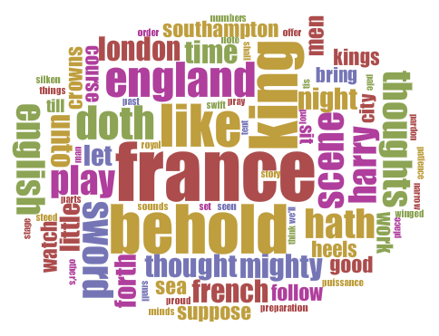
Just as analysis and close reading of the chorus can reveal its purpose, distance reading provides a more quantitative insight on the values of the Chorus. The chart on the right displays the relative frequencies of unique words the Chorus uses throughout the play. The majority of the Chorus’ lexicon consist of words describing bravery and majesty, the most notable being “behold” which the Chorus uses nine times throughout the play. The word “behold” demands our reverence and elevates Henry above us as the Chorus commands us to look in awe upon the actions of the play. This ties the Chorus back into the role of praiseful narrator, which makes sense as distance reading is derived from simplified surface reading. The graphic also supports the Chorus’ role in setting the scene, with the most frequent word being “France.” Over half of the play occurs in France, making the seemingly disproportionate appearance of “France” justifiable for a narrative Chorus.

Works Cited
Bednarz, James P. “When Did Shakespeare Write the Choruses of Henry V?” Notes and Queries 53.4 (2006): 486-89. Oxford Journals. Web. 28 Oct. 2015.
Charney, Maurice. All of Shakespeare. New York: Columbia UP, 1993. Google Books. Web. 28 Oct. 2015.
Crunelle-Vanrigh, Anny. “Henry V as a Royal Entry.” Studies in English Literature, 1500-1900 47.2 (2007): 355-77. JSTOR. Web. 28 Oct. 2015.
Danson, Lawrence. “Henry V: King, Chorus, and Critics.” Shakespeare Quarterly 34.1 (1983): 27-43. JSTOR. Web. 28 Oct. 2015.
Gutierrez, Christina. “The Mirror of All Christian Kings: Choral Medievalism in Henry V, Text and Production.” Shakespeare Expressed: Page, Stage, and Classroom in Shakespeare and His Contemporaries. Ed. Sarah Enloe, Kathryn McPherson, and Kathryn Moncrief. Lanham: Fairleigh Dickinson UP, 2013. 157-68. Google Books. Web. 28 Oct. 2015.
“The History of Theatre.” Treading the Boards: Theater Fundamentals. Films on Demand, 2010. Web. 28 Oct. 2015.
Odell, George C. D. “Shakespeare’s Use of the Chorus.” Shakespeare Online. Web. 28 Oct. 2015.
Royal, Derek. “Shakespeare's Kingly Mirror: Figuring the Chorus in Olivier's and Branagh's Henry V.” Literature Film Quarterly 25.2 (1997): 104-10. EBSCOhost. Web. 28 Oct. 2015.

