Allison Carlos
ENG 101-016
Dr. Cooke
10/12/2016
Issues within the Community and Relationships in Lorraine Hansberry’s ‘A Raisin in the Sun’ and During the 1950’s
In the 1950’s and later there continued to be broken relationships in communities like the suburbs of Chicago. These broken relationships were a result of segregation and the impact segregation had on both African Americans and white people. These impacts of segregation are seen in Lorraine Hansberry’s play, A Raisin in the Sun, and are verified by personal events in the book To Be Young, Gifted, and Black. These aspects of the community are then examined in the media by providing both African American and white community views about segregation. Then by looking at the civil rights movement we can see that these views were challenged. These community aspects in the 1950’s are analyzed so people are more aware of some of the reasons for the broken relationships at the time and the fact that similar relationships are still present today, so that they can be prevented.
Lorraine Hansberry (1930-1965)
A Raisin in the Sun
1966
Rose Library Special Collections
The script for Lorraine Hansberry’s play, A Raisin in the Sun, from the Rose Library includes newspaper clippings describing the play, verifying how realistic the play is, and explaining the impact the play had on communities in the 1950’s. This play is a result of events from Lorraine Hansberry’s childhood, as we can see through the accumulation of her works in To Be Young, Gifted, and Black by Robert Nemiroff, and clearly shows some of the issues between races in society. In this play a family is strongly encouraged, even bribed, not to move into a white neighborhood so that they do not disturb the peace, but that is exactly what the white people in the community do to the family once they move in. This play clearly shows a preconception about African Americans that they are bad and will disturb the peace, and it also shows how this preconception affected the relationship between the family and the community.
Nemiroff, Robert., Lorraine Hansberry, James Baldwin, Louise Alone Thompson Patterson, and Thomas H. Wirth.
To Be Young, Gifted, and Black : Lorraine Hansberry in Her Own Words
1969
Rose Library Special Collections
This book is a collection of Lorraine Hansberry’s writings from throughout her childhood. By reading the chapter about her time in Chicago we can see that she faced a lot of discrimination throughout her childhood, but we can also see that she was surrounded by many prominent activists. In one part of the book Hansberry explains that at only eight years old while living in a predominantly white neighborhood mobs surrounded her house, a missile just missed her, and she was “spat at, cursed, and pummeled (Nemiroff, p.21). This is clearly inspiration for one of the scenes in A Raisin in the Sun. These accounts of Hansberry’s life help the reliability of the portrayal of a Chicago community and the relationships in her play. Other accounts of what it was like in Chicago in the 1950’s can be found in newspaper articles like Teens Tell Views on Segregation from the Chicago Daily Tribune.
Joan Beck
Teens Tell Views on School Segregation
1956
Chicago: Chicago Daily Tribune
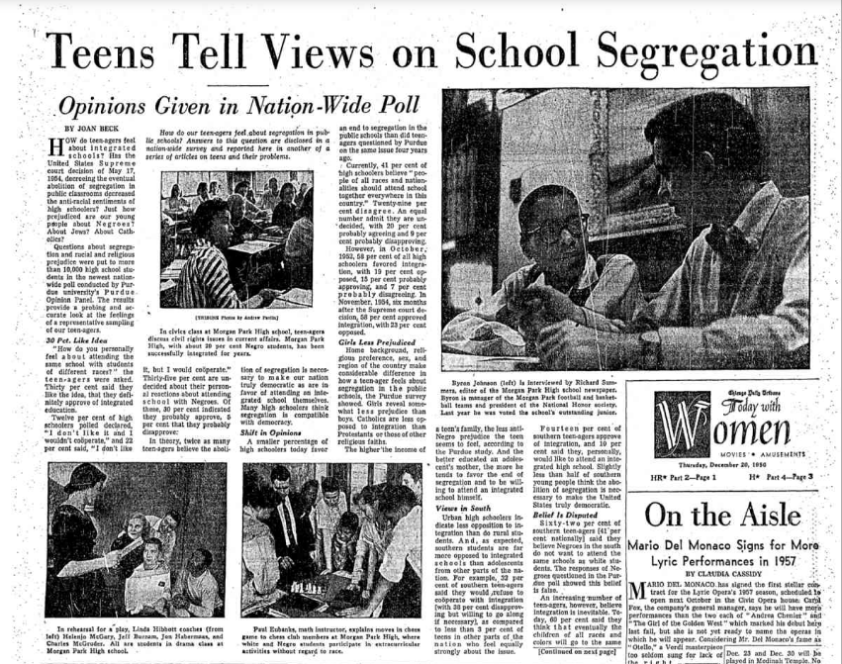
This newspaper article provides schoolchildren’s views about segregation before and after the supreme court decision to abolish segregation. This is important because it shows that teens thought they would be open to an integrated school system, but when it came down to actually integrate African Americans into other schools, more teens were opposed to the decision. This newspaper article supports the fact that relationships between races were complicated, and became even more complicated when the relationships were forced on each other. Even though there was still this split between African American’s and white people, we see people come together to fight this through strikes, protests, marches, and many more actions.
Anonymous
Five Men and Women with Strike Signs in Front of Fifth Avenue Hospital
1955
Robert Langmuir African American Photographs
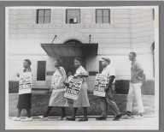
This photograph depicts a group of African Americans striking for better pay. This is important because it shows that people were doing something about the inequality in Chicago and being their own advocates. This photograph shows a community issue over unequal pay in the 1950’s and how people dealt with it. We do not know how the white community responded to this specific event, but the point is that people were coming together, and forming healthy relationships to do something about the inequality they were facing.
Anonymous
Rev. John W. Williams, Rosa Parks and Another African American Woman with March on Washington for Jobs & Freedom Pins on
1959
Robert Langmuir African American Photographs
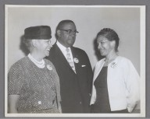
This photograph was taken in 1959 and it shows that there were still issues with segregation during this time. We can see three African Americans including Reverend Williams, and Rosa Parks coming together and advocating for what they believe in because segregation and discrimination created a divide between races. This photograph shows that there was a community of people fighting for African American rights and that, even though the reasons for these relationships was not ideal, not all relationships during this time were bad or broken. Many of the relationships between African Americans were focused on improving the lives of their communities, like the type of relationship is this picture.

