The Twist of Social Inequality & Greed Presented in

Lillian Hellman’s The Little Foxes

Jiawen Zhang (Jemma)

Oct. 26th, 2016

Author: Wendy Wasserstein
Lillian Hellman: An Unfinished-Woman
June. 7th 1999
Copyright 1999 Reed Business Information, Inc.

This is a portrait of Lillian Hellman, used as the cover for her memoir Lillian Hellman: An Unfinished-Woman, which is a rich, surprising, emotionally charged portrait of a bygone world -- and of an independent-minded woman coming into her own. The image of Lillian Hellman presented in the memoir provides reason for her literary achievements and the formation of her unique and bold perspectives on all kinds of social concerns.

Introduction:
Lillian Hellman, as a female author who was brave enough to reflect all kinds of social issues in her play, created the story of The Little Foxes---a play about a family falling apart to fight for properties & legacies. The play was a microcosm of the avaricious atmosphere of the society back then because of gender inequality.
The Little Foxes was created right after the Great Depression, during when because the job opportunities were too scarce, the states passed the law against hiring women. However, as the jobs were not highly paid for working men, the "bread-winning" responsibility also fell on women---resulted in women illegally working long hours for low wages. Meanwhile, women were still expected to fulfill their traditional gender role according to social norms which was to undertake all housework as well as keeping the whole family together.
This exhibit connects the social concern behind the story of Giddens family with the stereotypical gender roles and the still-not-yet-reached true equality between men and women from sociological perspectives.

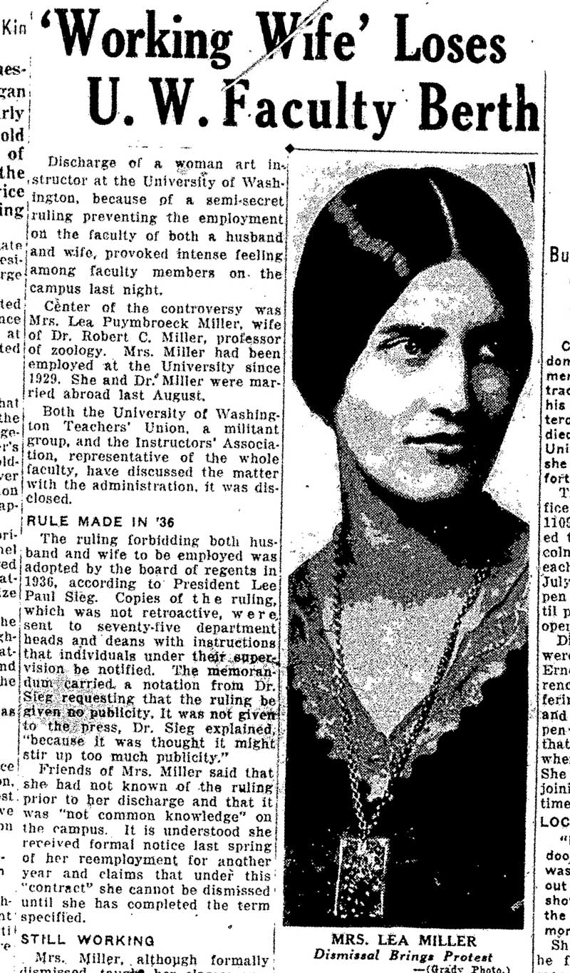
Author: Lea van Puymbroeck Miller
‘Working Wife’ Loses U.W. Faculty Berth
Jan.3rd 1938
Seattle Post-Intelligencer

This image is a newspaper article written by Professor Miller of the University of Washington, which violated the law that denied married women their own jobs. Men were favored to be heads of households and privileged over women for job opportunities during the Great Depression. Women were given lower paying jobs such as sewing, bookbinding, and working in school lunch programs. The different standards of expectations for two genders created the twisted values and mindset for many women that the amount of pressure and workload they carried were far from reasonable. Under this circumstance, it is easy to understand, why the avaricious characteristics of the sister---Regina in The Little Foxes existed and how her greed was inspired.

One reason I believe for the growth of avarice in the family is the petty brother Oscar who tried to manipulate everything that he could control. His personality fully interpreted what gender superiority and ruthlessness was. However, the economic recession did not allow him to fulfill his lust for power and money. So marrying Birdie was an act upon nothing but acquiring her family plantation.

https://www.youtube.com/watch?v=HXvS5DzYzc8
Video uploader (author): Elizabeth Hodes
The Little Foxes, Act I, Part 3 (conclusion)
Jul. 7th, 2012

This is a video of a recent version of The Little Foxes play. The ten-minute clip showed Oscar’s wife, who had been innocent and trustful, was brutally punished by Oscar when she tried to warn their daughter Alexandra from marrying her cousin Leo. The marriage was set up by Oscar and his sister, Regina, initially for the purpose as a means of obtaining Regina’s husband-Horace’s money. The rampant greed in Gidden’s family had the siblings act unscrupulously to achieve their goal. It was pathetic that neither Oscar nor Regina got married because of love.

Another scene in the play was Oscar stomach-punching Birdie over and over again---ratcheting up abuse. It leads to the other derivative social concern of The Little Foxes I paid special attention to, which is the intimate partner violence (IPV). IPV has been a constant and prevalent issue that was not brought up until roughly a century ago.

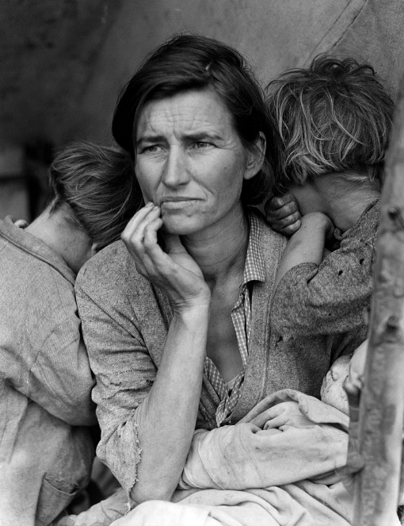

Author: Dorothea Lange
Migrant Mother
March, 1936
Nipomo, California, US

This is a picture of a lost mother of seven children in 1936. It’s not hard to image the difficulty of raising that many children, not to mention during the Great Depression. Having more children than desired was nothing rare. Part of what caused the phenomenon, was the prevalence of intimate partner violence, which includes rape within marriage. (*p.s. Since males in most circumstances still lead the dominant role in families, the studies upon the IPV are of which males apply to female.) Back in the time Lillian Hellman created The Little Foxes, there were not any laws protect women from such abuse. The bottled up but nowhere-to-vent grievance turned into venomous greed in Lillian’s story. She showed the audience/reader that the accumulated gender inequality might eventually lead to the arouse of the seamy side of humanity---which is particularly the avarice in the play.

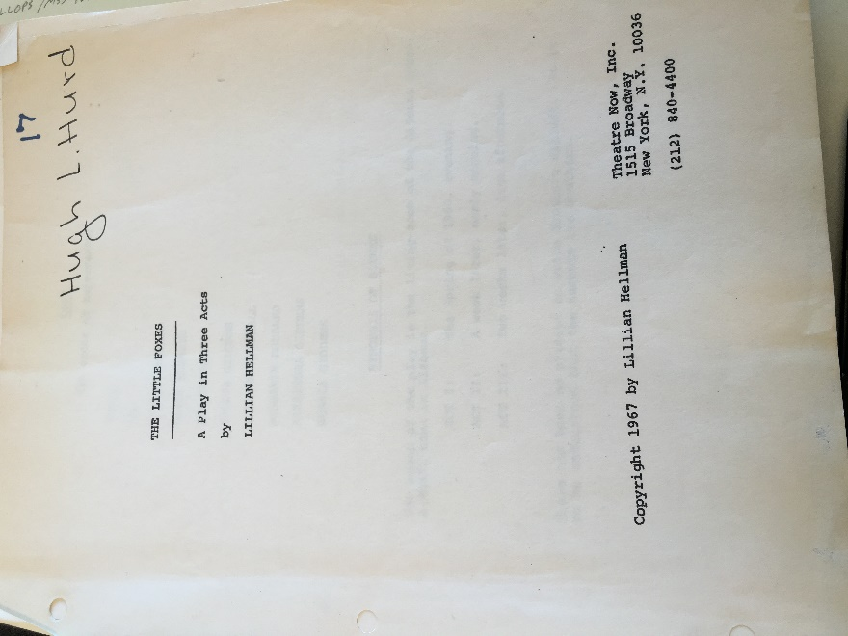

Author: Lillian Hellman
The Little Foxes
December 1967
Play script

The is the revised play script released in 1967, almost 30 years after the first edition was published. The melodrama of the Giddens was put on the stage again and won the greatest possible applause from the public and the critics. (*p.s. Hand-written cards were included in Rose Library collection which I did not take photos of, saying how watching the play had been enjoyable though the characters setting was too brutal to be redeemed. But on the other hand, the new version of the text gives prominence to the weakness of the kind pastoralists, such as Oscar’s wife Birdie, that though innocent, they were as well graciously impractical, as opposed to the very spirit of ruthlessness of Capitalism---the historical background of The Little Foxes.

The play was not a piece work that make the audience 100% desperate. In the end, Regina indeed was left with a great amount of wealth she had been craving for, but completely alone. She lost the respect and love even from her own daughter. The cruelty of humanity and how dangerous greed could evolve were incisively revealed by The Little Foxes. The play was also Lillian Hellman’s way of building the bridge for the public to link the content to the real social issue of gender inequality. At the end of the day, however, as audience, the very best thing we could do is to reflect to ourselves---how can we outdo our bit to fight against gender inequality?

