Stefano De'Rossi
English 101-13
Assignment 1
GDP and Class
GDP, or gross domestic product, is a commonly used word in the field of economics which refers to the total worth of a country’s revenue and consumption. A country’s GDP is usually used to track its nation’s economic health; if a country’s economy is suffering during a certain period of time, its GDP will indicate a severe drop from the norm. Because of a GDP’s wide scope, economists and investors usually track it closely to inform themselves on the future of a country’s economy. Often times, a lower relative GDP will indicate lower overall earnings or lower stock prices, while a higher relative GDP will point to a booming economy.
When it comes to breaking down the factors which contribute to GDP, one must understand first the major contributors to a country’s GDP. In modern-day United States, for example, most of the country’s revenue is brought in from finance, insurance, real estate, and trade. Simply put, most of the money made by our country comes from persons’ spending on homes, insurance, and investment, along with a constant of consumer spending. Interestingly, the breakdown of contributors to GDP over the years is very dynamic, meaning different systems fluctuate in money generation throughout the years. For example, in the first quarter of 2018, manufacturing revenue accounted for 4 times as much revenue as it does now. This, though a very complex topic, is very common, as certain industries may suffer or profit in any given year. Usually, when one industry suffers, another will take its place in revenue generation, which explains why the US GDP has steadily increased over time; if all industries were to be affected in the same way, we would see a drastic dip in the GDP.
This past year, as one may suspect, coronavirus had a devastating effect on the economy. As mentioned earlier, lower GDP signifies lower earnings and correspondingly higher unemployment, both of which were rampant during the pandemic. As a result, the reported GDP during 2020/21 was the worst shrinking of the US economy since, well, ever. For reference, the economy shrank at 32.9% during 2020’s second quarter; in the stock market crash of 2008, the market suffered a mere 8% decrease. 1.4 million people filed for unemployment in one week during July, while the adverse effects of Covid-19 prevented those same people from finding a new job. The following figure shows a measurement of the percent change from the preceding period, showing which fluctuations in the economy have done the most damage. This year clearly won the gold medal. 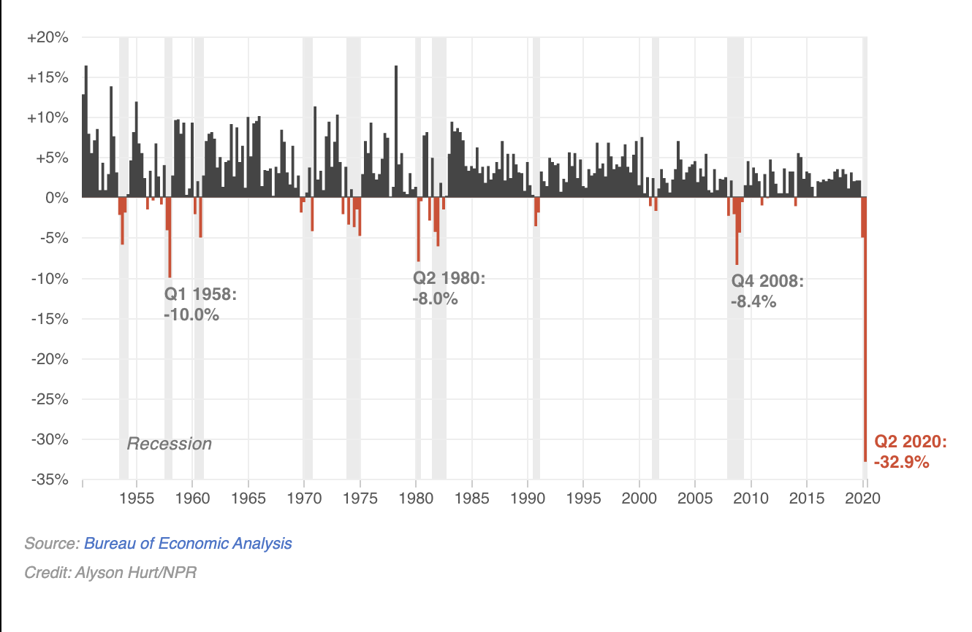
As mentioned before, however, the US has proved exceptionally well at maintaining a high GDP, in this case due to different thriving industries and a large amount of federal relief. For example, dental offices during the month of May added nearly 250,000 jobs. For whatever arbitrary reason, consumers began to set up appointments for teeth cleaning during the pandemic, which led to an increase in demand for jobs, which led to an increase in employment numbers (for the dental industry, at least). For every Six Flags and Delta that lost massive income, a construction business or factory gained immense revenue. Even with these fluctuations in industry’s incomes, though, the country still suffered largely. Waves of restaurant bankruptcies plagued the country for many months, and the lower class largely suffered in all senses of the word. The governmental stimulus payments certainly helped in offsetting the fall of wages and salaries, finally helping lower class families buy goods and pay their rent. And although the government payments have kept businesses and families intact, the effects of coronavirus have clearly taken their toll, as seen through the GDP projections.
Going forward, the new President Joe Biden has proposed a $1.9 trillion relief package in order to counter the GDP’s large drop. It is important to assess where all the money is planned to go, as his comprehensive plan aims to assist in all aspects of the economy. By providing relief for paid leave, school funding, transit systems, local governments and more, Biden has created a rounded plan to repair the economy, industry by industry. For example, the President’s relief for transit systems calls for $20 billion pumped into transit agencies; this not only helps transportation staying in business, which is extremely essential, but also saves many employees’ jobs. By feeding the industry itself while keeping people employed, the integrity of the industry is maintained while workers can keep their jobs and continue to produce for the country’s GDP.
Regardless of the past year, however, the meaning of GDP has slowly faded over time. If you look at a graph of US GDP, you’d see that since 1979, the economy has been steadily improving, which might indicate a nearly flawless economy. But this is far from the truth. The United States’ huge wealth gap is bigger than ever, with an estimated 11.5% of world GDP held in offshore accounts owned by the top one-tenth of a percent. In addition, as of 2012, 160,000 families (.04% of the US population) own almost as much money as the bottom 90% of citizens. These types of statistics are precisely why the use of GDP has become, in my opinion, obsolete. Under no circumstances should GDP indicate massive growth while millions of Americans live in poverty and experience decrease in wages constantly. The GDP may function in estimating a country’s net gains, but it is in no way effective at assessing the condition of a country’s lower class, especially when most of the GDP gains come from the top 1%. Factors like minimum wage, unemployment, and disproportionate taxes all may contribute to this massive wage gap, but without reform, the system will remain flawed, and the GDP will still indicate a booming economy.
With regard to GDP, there are several actions that can be taken in order to better our method of tracking economic progress. As a country, the US has always tended to measure success in terms of the most successful business and individuals, instead of in terms of how each social class fares as compared to the others. Granted, there may always be some type of disparity between classes, as nothing can ever be perfect, however when there are steps that can be taken, our lack of action just worsens our countries condition. As of today, only one in three American workers feel “engaged” with their work; whether it be because of a low minimum wage or longer hours, it is safe to say most of these suffering workers belong to the lower and middle class. With increasing tax breaks for the rich and the amassed money in the aforementioned offshore accounts, there is little room for inclusive economic prosperity. Before we, as a country, can fix these problems, we must alter the way we measure national economic growth, both in who we seek to support and who we seek to hold responsible. Especially during a pandemic, the disparity between classes has become ever so clear, through low-income communities suffering terribly and the detrimental effects of working for minimum wage during a worldwide catastrophe. If a comprehensive plan is created to address these disparities and redistribute wealth, we may finally be able to brag about our GDP- not as the massive earnings of our rich, but instead, as the prosperity of all classes, so that everyone may live with the benefits of healthcare and disposable income.

Bibliography
Kramer, L. (2020, October 29). What is gdp and why is it so important to economists and investors? Retrieved March 01, 2021, from https://www.investopedia.com/ask/answers/what-is-gdp-why-its-important-to- economists-investors/
Rachel Siegel, A. (2021, January 28). 2020 was the worst year for economic growth since World War II. Retrieved March 01, 2021, from https://www.washingtonpost.com/business/2021/01/28/gdp-2020-economy-recession/
Siegel, R. (2021, January 28). What's in BIDEN'S $1.9 Trillion emergency coronavirus plan. Retrieved March 01, 2021, from https://www.washingtonpost.com/business/2021/01/14/biden-coronavirus-stimulus-plan/
Reeves, R. (2019, April 29). Capitalism is failing. people want a job with a decent wage – why is that so hard? Retrieved March 01, 2021, from https://www.brookings.edu/opinions/capitalism-is-failing-people-want-a-job-with-a- decent-wage-why-is-that-so-hard/
Boushey, H. (2019, May 14). The economy isn't getting better for most AMERICANS. but there is a fix. Retrieved March 01, 2021, from https://www.brookings.edu/opinions/the- economy-isnt-getting-better-for-most-americans-but-there-is-a-fix/

